# New York University Abu Dhabi Neuroscience of Language Lab Lab Manual

*Last updated: May 2023*

## QR Code to View Online

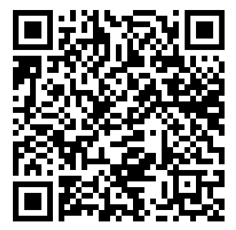

## About this guide

This guide is intended as a guide for all MEG Lab users at NYUAD. It aims to provide the user with information sufficient for a quick start in using the MEG system. It contains information about safety, software/hardware, and experimentation. This guide is not intended to explain how to prepare your experiment in software, or how to analyze data. It should be revised and updated yearly to maintain usability.

## Contents

[**New York University Abu Dhabi  
Neuroscience of Language Lab  
Lab Manual 1**](#_8x5sfle9i8n1)

About this guide 1

Contents 1

BEFORE YOU BEGIN 3

CONTACTS 3

GETTING STARTED 4

Connection diagram 4

Magnetically-shielded room 5

Data acquisition system (DAQs) 8

MEG system computer 8

Stimulus Computers 10

Helium monitor 12

RECRUITING PARTICIPANTS 13

1. How to recruit 13

2. Scheduling participants 13

RUNNING THE EXPERIMENT 13

1. Preparing paperwork: consent & participant’s information 13

2. Before participants arrive 14

3. Digitizing head shape 20

4. Preparing subject in MSR 23

5. Check sensors, set parameters 27

6. Record 30

7. Common noise patterns 31

8. Finishing up 36

9. Cleaning and Uploading Data 36

TROUBLESHOOTING 37

Fixing Noisy Waveforms on the DAQ 37

Fixing dead waveforms on the DAQ / Restarting DAQs / Power Shutdown 38

Marker Coil Errors 38

Trigger Box Not Working 39

Server is disconnected 39

FastScan is not working 40

Liquid helium refill fails 40

Eye Tracker won’t turn on 40

MEG MAINTENANCE 40

Vacuuming helium transfer tube 40

Changing DAQ batteries 41

Changing Marker Coil Batteries 41

Making Sure Helium System is Operating 41

OTHER GUIDES 42

## 

### BEFORE YOU BEGIN

1. Our MEG system uses liquid helium to keep our SQUID sensors cold (-269°C, -452°F). If the helium tank leaks, the liquid helium will immediately boil off. This can cause rapid suffocation and severe frostbite. Handle with care. Especially don’t shock the dewar. If you feel anything strange while doing an experiment (i.e., you suspect a helium leak), open the MSR and release the subject immediately. Do not leave the room with a subject in the MSR.
2. Don’t bring any magnetic things (e.g., a magnet) into the MSR. Strong magnetic fields may cause damage to the MEG sensors.
3. Do not use the MEG control computer (MEG CONTROL) except for MEG use.
4. Most importantly, do not install any software. This may cause the system to not work properly.

### CONTACTS

| **NeLLab Staff** | |
| --- | --- |
| **Liina Pylkkänen**  Principal Investigator/ Co-director  Located full time in New York  A2-109 | **Alec Marantz**  Principal Investigator/ Co-director  Located full time in New York  A2-109 |
| **Kainaath Mumtaz**  MEG Lab Admin  A2-106F | **Dustin A. Chacón**  Research scientist  A2-106E |
| **Kyra Wilson**  Research assistant  A2-008 | **Sherine Bou Dargham**  Research assistant  A2-106D |
| **MEG Lab AD (general)**  [meglab-nyuad-group@nyu.edu](mailto:meglab-nyuad-group@nyu.edu) |  |

| **MEG Experts** | |
| --- | --- |
| **Jeff Walker**  [jeffrey.walker@nyu.edu](mailto:jeffrey.walker@nyu.edu)  Located full time in New York | **Yoshiaki Adachi**  [adachi@ael.kanazawa-it.ac.jp](mailto:adachi@ael.kanazawa-it.ac.jp)  Located full time in Japan |
| **Jun Kawai** j-kawai@neptune.kanazawa-it.ac.jp  Located full time in Japan | **Osama Abdullah**  Core platforms at NYUAD  [oa22@nyu.edu](mailto:oa22@nyu.edu)  C1-029 |

### GETTING STARTED

#### Connection diagram

The hardware components constituting the (legacy) MEG system:

### 

#### Magnetically-shielded room

* **Lights**: switch is located by the door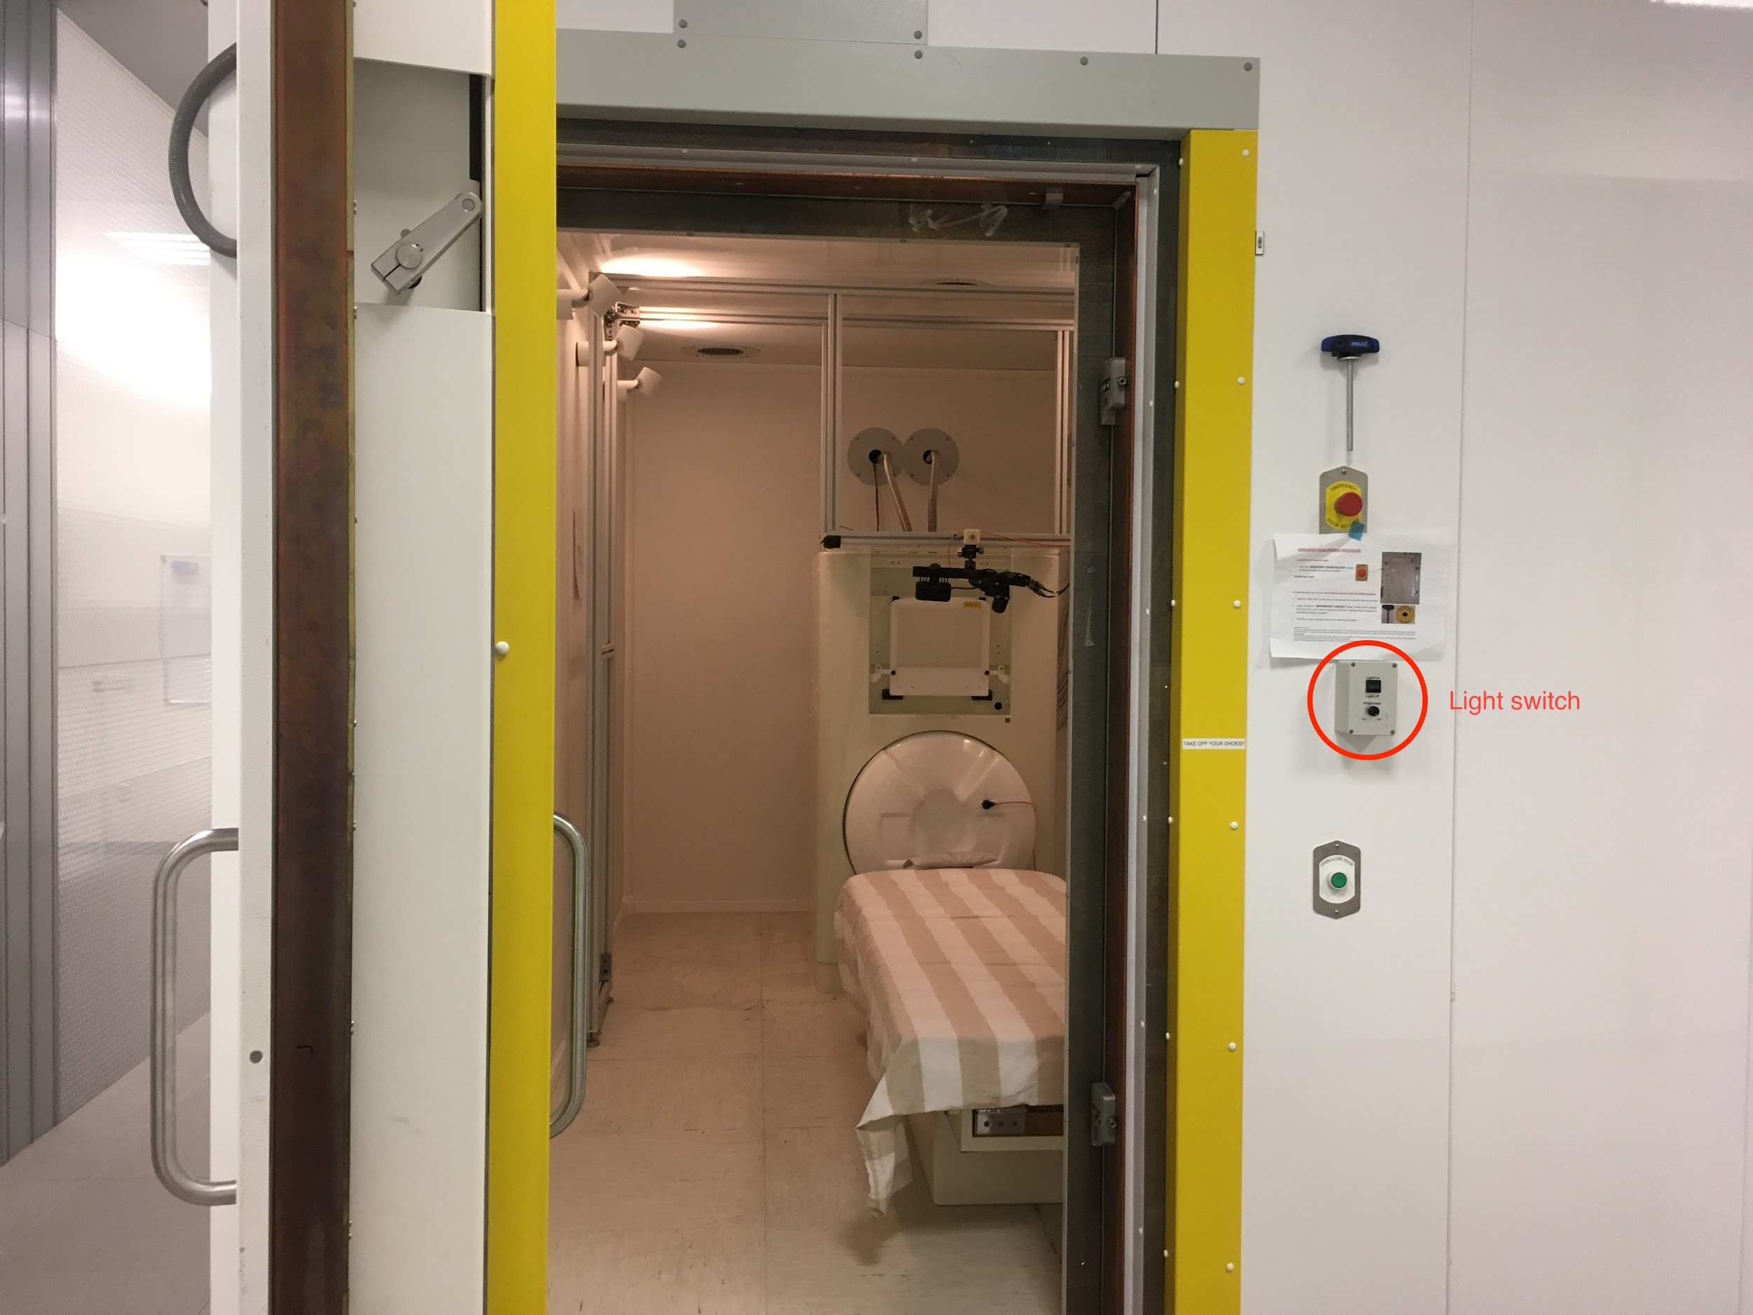
  + Backup battery is located in one of the office spaces connected via yellow cables
* **Dewar**: contains liquid helium that submerges SQUID sensors spread across the helmet
* **Marker box**: connects the head position indicator coils (marked with 5 colours)
* **Amplitude switches:** controls the signal strength of the marker coils

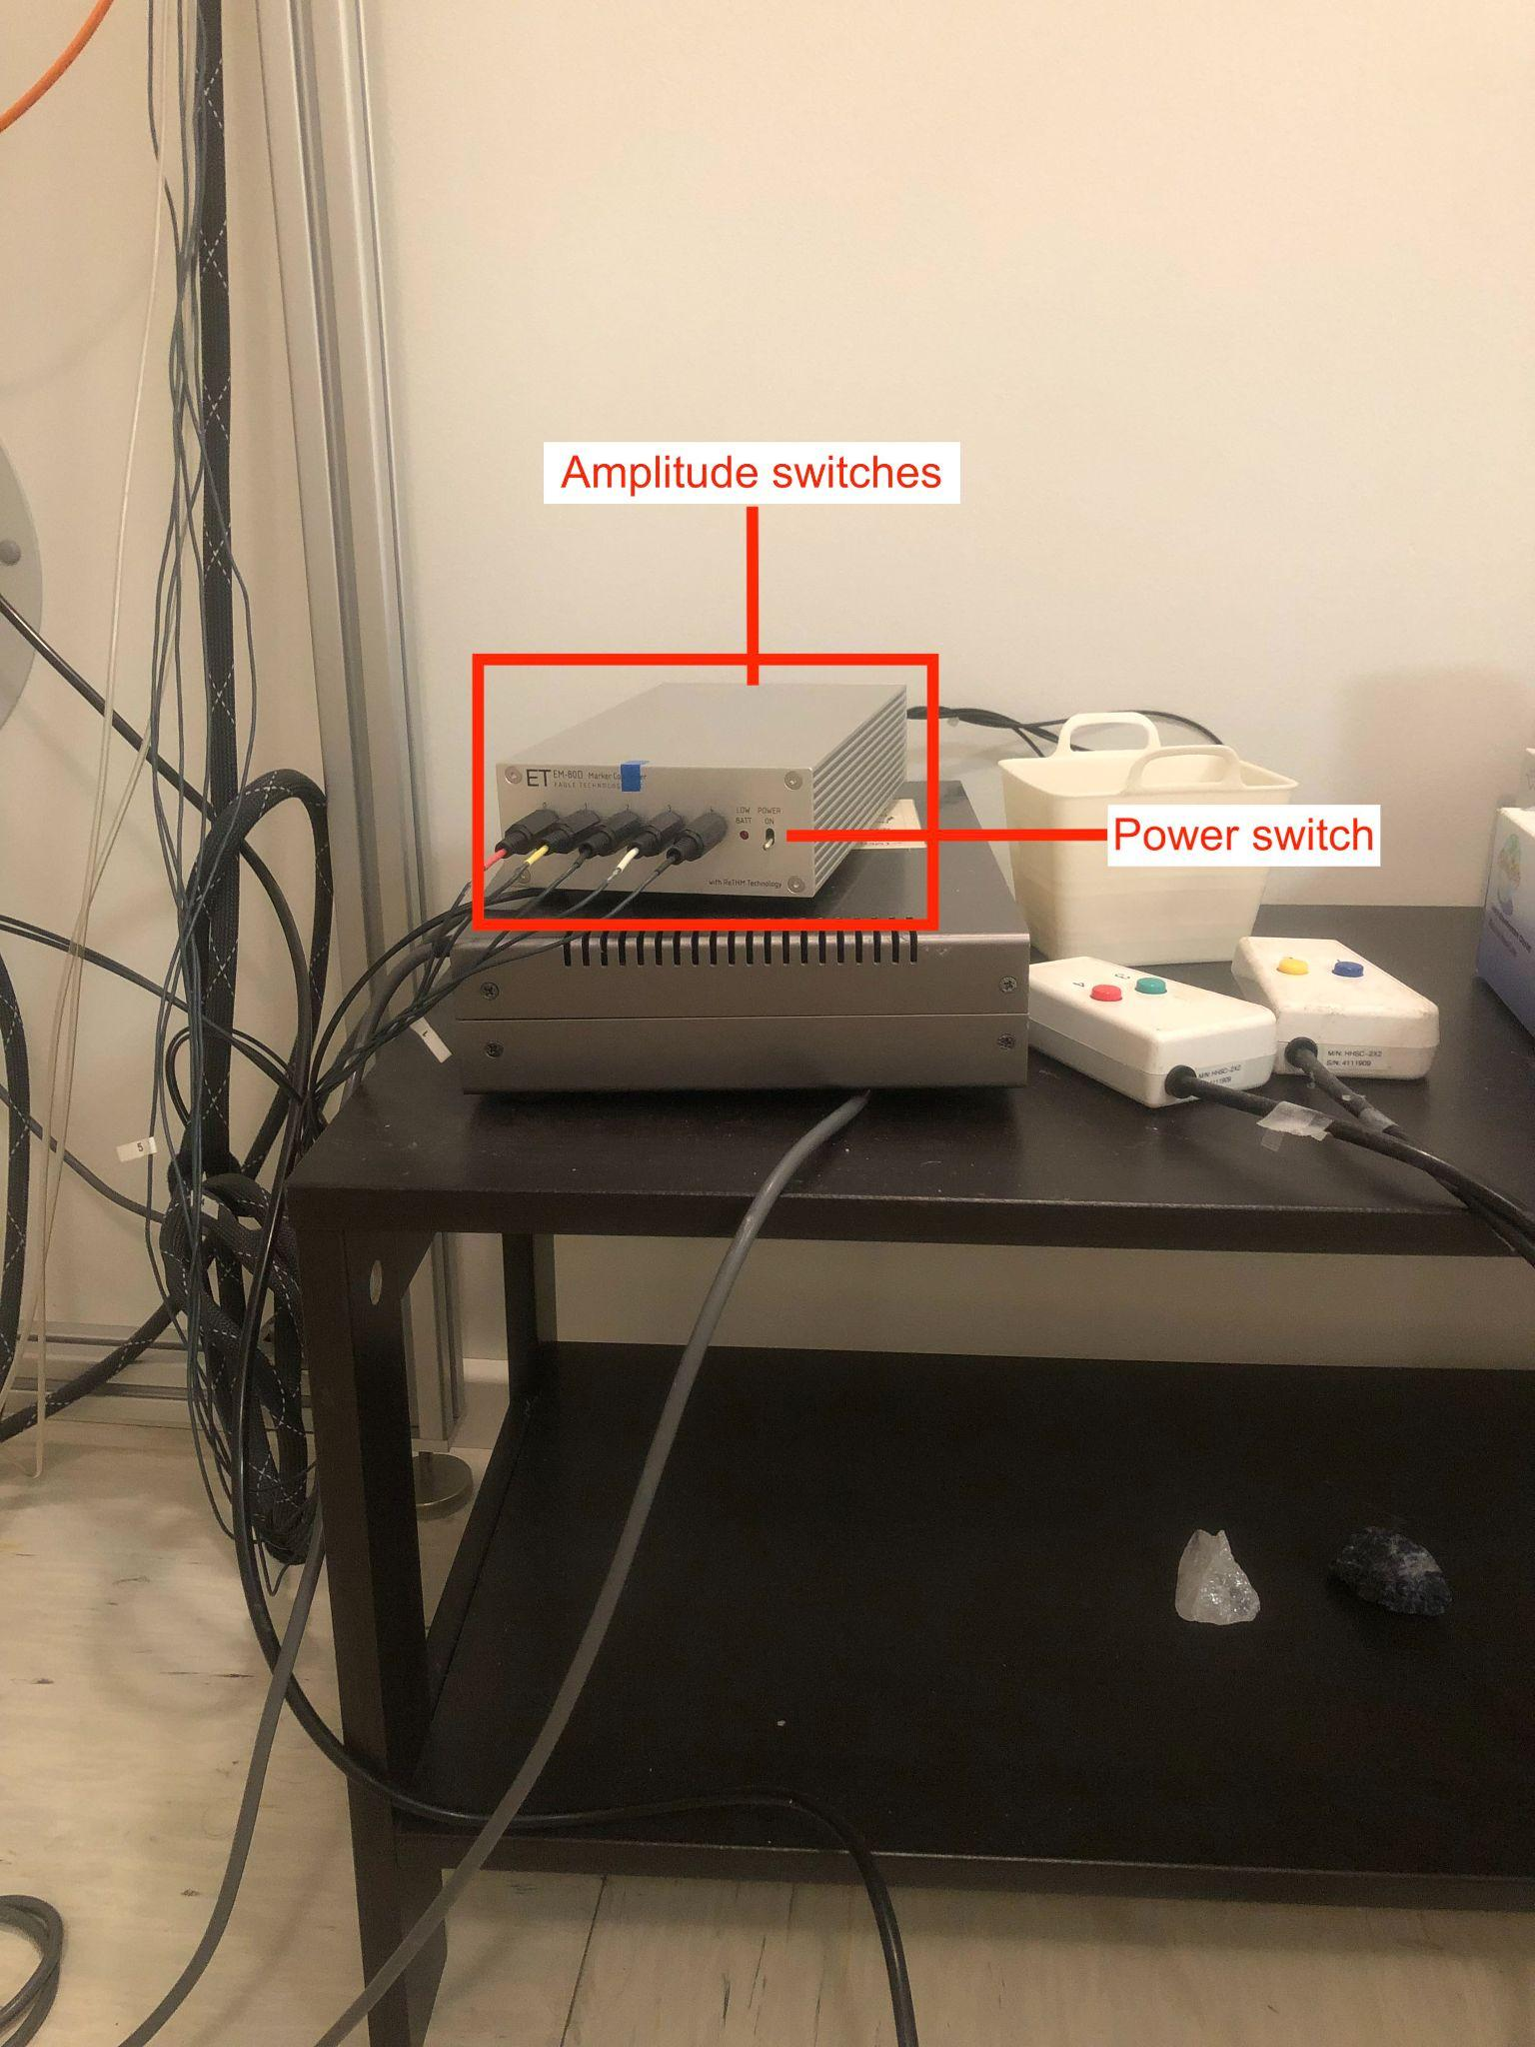

* **Foam insert headphones**
* **Projector**: back-projects stimulus onto a screen; remote control is outside the room.
* **Heater cable**: keeps frost and ice from forming on DEWAR; switch is located at the back of the MSR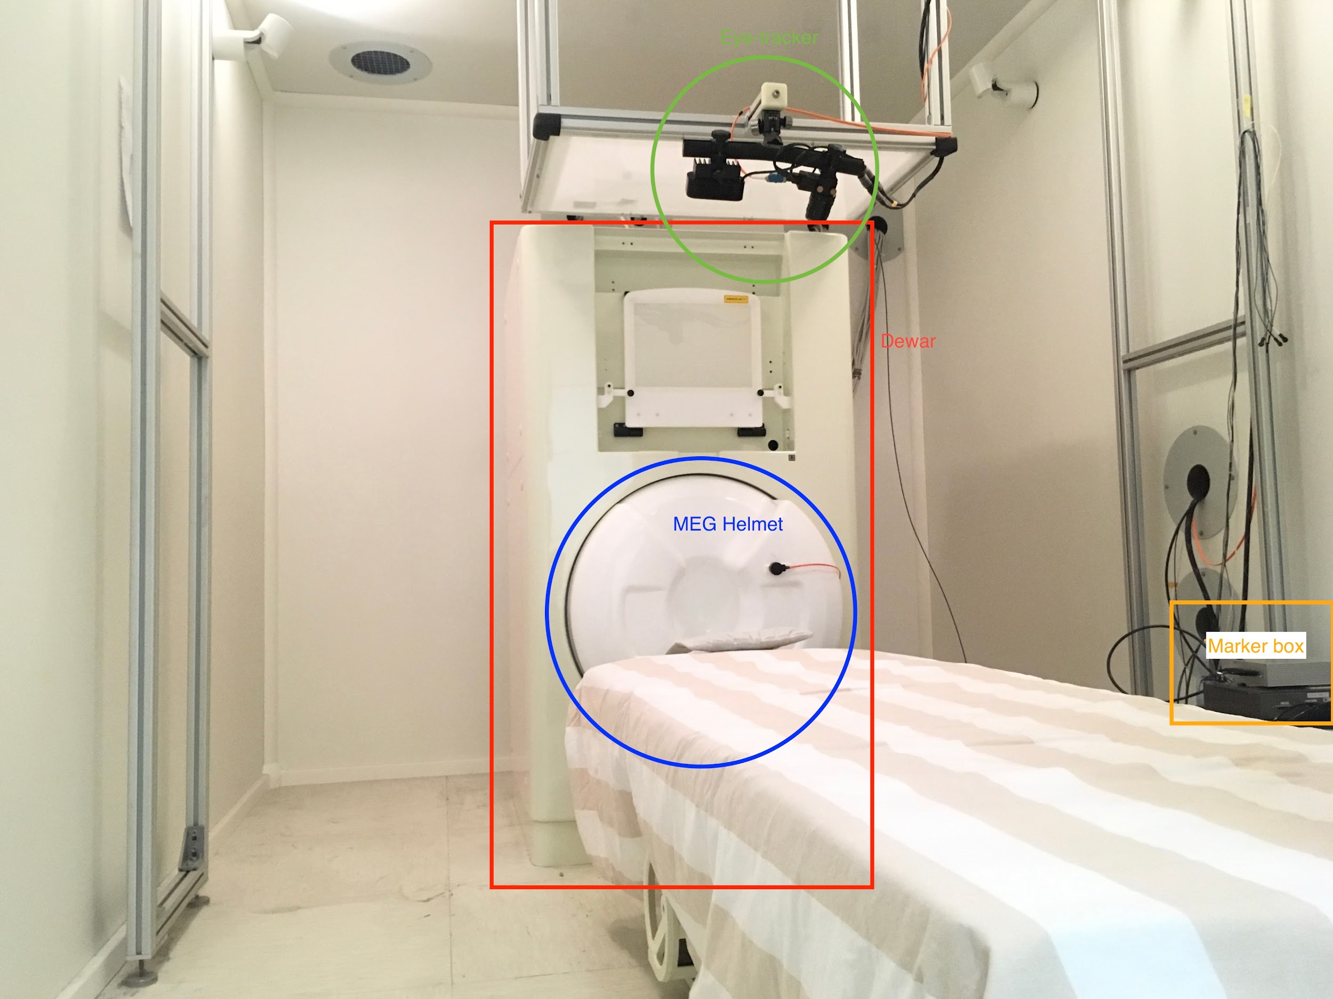

#### Data acquisition system (DAQs)

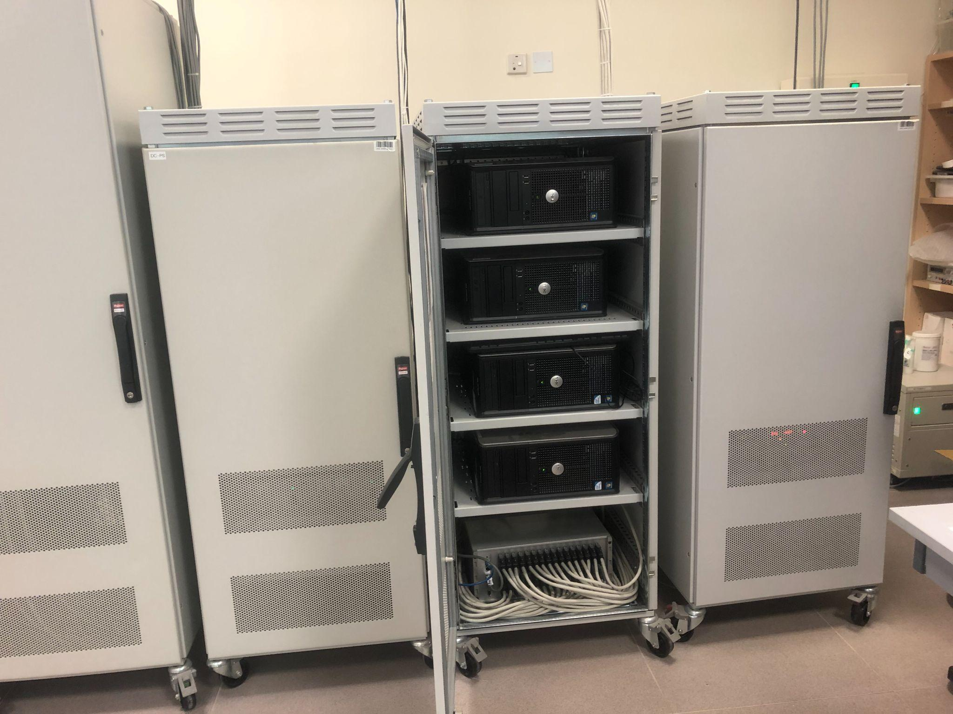

* Consists of four PCs working together, interfacing with MEG160 during data acquisition.
* The DAQ units are located in a cabinet labeled “DAQ”.
  + The units are labelled as ‘DAQ0’, ‘DAQ1’, ‘DAQ2’, and ‘DAQ3’.
  + The last time the system battery for DAQ0 was changed on February 4, 2020.
  + Once changed, the BIOS settings might need to be updated. To enter the setting page, strike F2 while the system is booting.
    - Make sure Power Management is Enabled.
    - Make sure Low Power Mode is Disabled.
  + In case one/some of the DAQs won’t boot, try turning it on by manually pressing the power button on the unit.
  + Inform other lab members if things like that happen. Chances are, they have encountered similar/same problems.

#### MEG system computer

#### 

* Password: **amaike1**
* Interfaces with the DAQs, the sensors of which are displayed on four monitors vertically arranged next to this machine.
* Where raw MEG recordings and marker measurements live.
* Where MEG160, our data acquisition software, lives.
* When you are running an experiment, the real-time sensor data you see isn’t very intuitively organized. Roughly, the channel numbers correspond to these sensor types and these head areas.
  + Channels 0-207: Axial gradiometers (MEG helmet sensors)
  + 208-223: Magnetometers (reference sensors used for noise reduction)
  + 224-231: Triggers
  + 232: Audio
  + 233: Photodiode
  + 234-238: Marker coils
  + 239-255: Not used

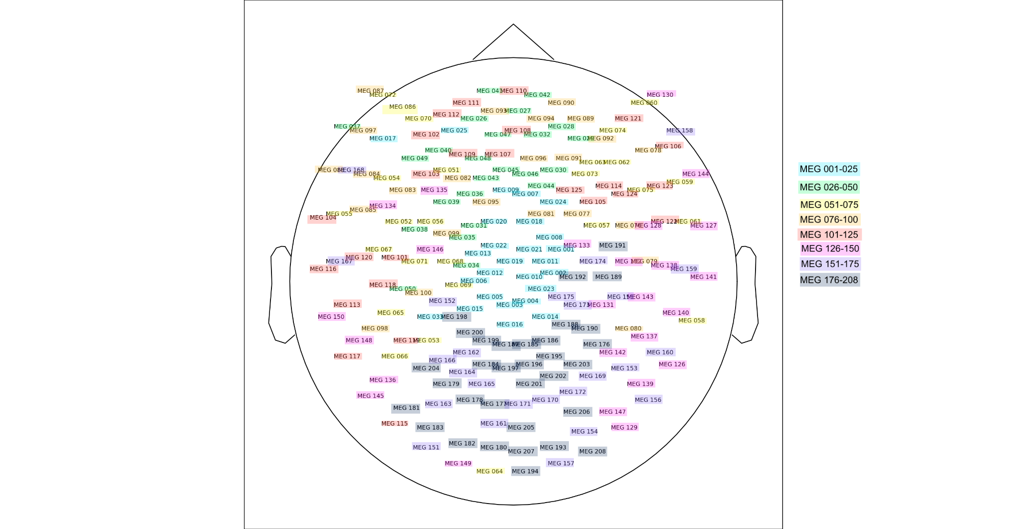

#### Stimulus Computers

| It is your choice to choose between the platform on which you present your stimuli. The new VPixx system has been tested with Presentation, Psych Toolbox, and PsychoPy. The legacy PC was used for Presentation, and the legacy Mac was used for PsychoPy. |
| --- |

* Legacy Stimulus Mac User: **stimulus2**
* Legacy Stimulus Mac Password: **stimulus**
  + Connects to the projector inside the MSR
  + Sends triggers from when executing experiment scripts to trigger box (note that in this system our triggers are ‘Peak’ meaning the values start low and go to a higher number)
  + Connects to the mixing board for sound mixing
  + Connects to the microphone through which we talk to participants from outside the MSR
  + **StimTracker**: interfaces with the trigger box and stimulus Mac

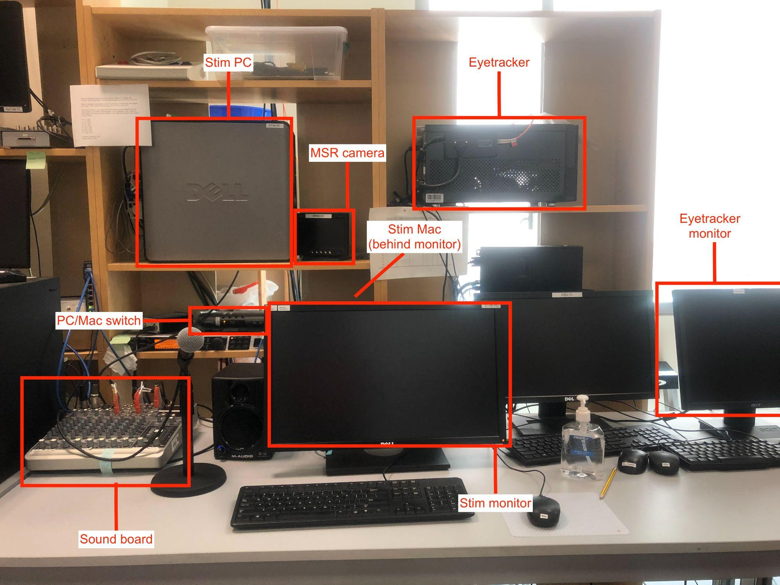

* VPixx PC User: **vpixx**
* VPixx PC Password: **vpixx**
  + PC connected to other components (projector, trigger box, etc.) via the VPixx control boxes

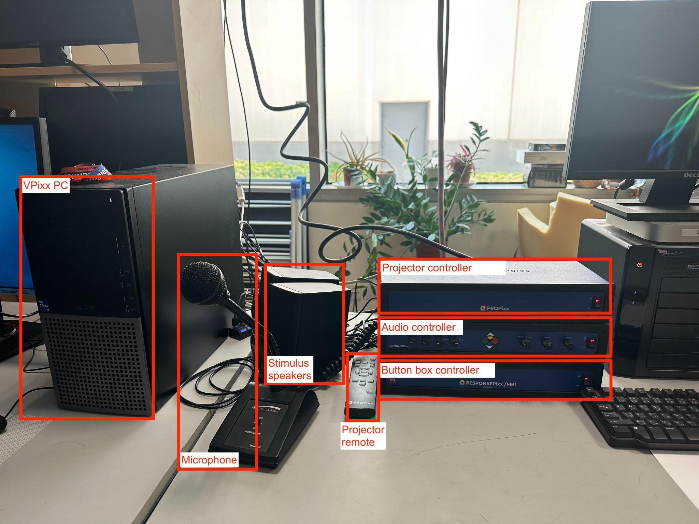



#### Helium monitor

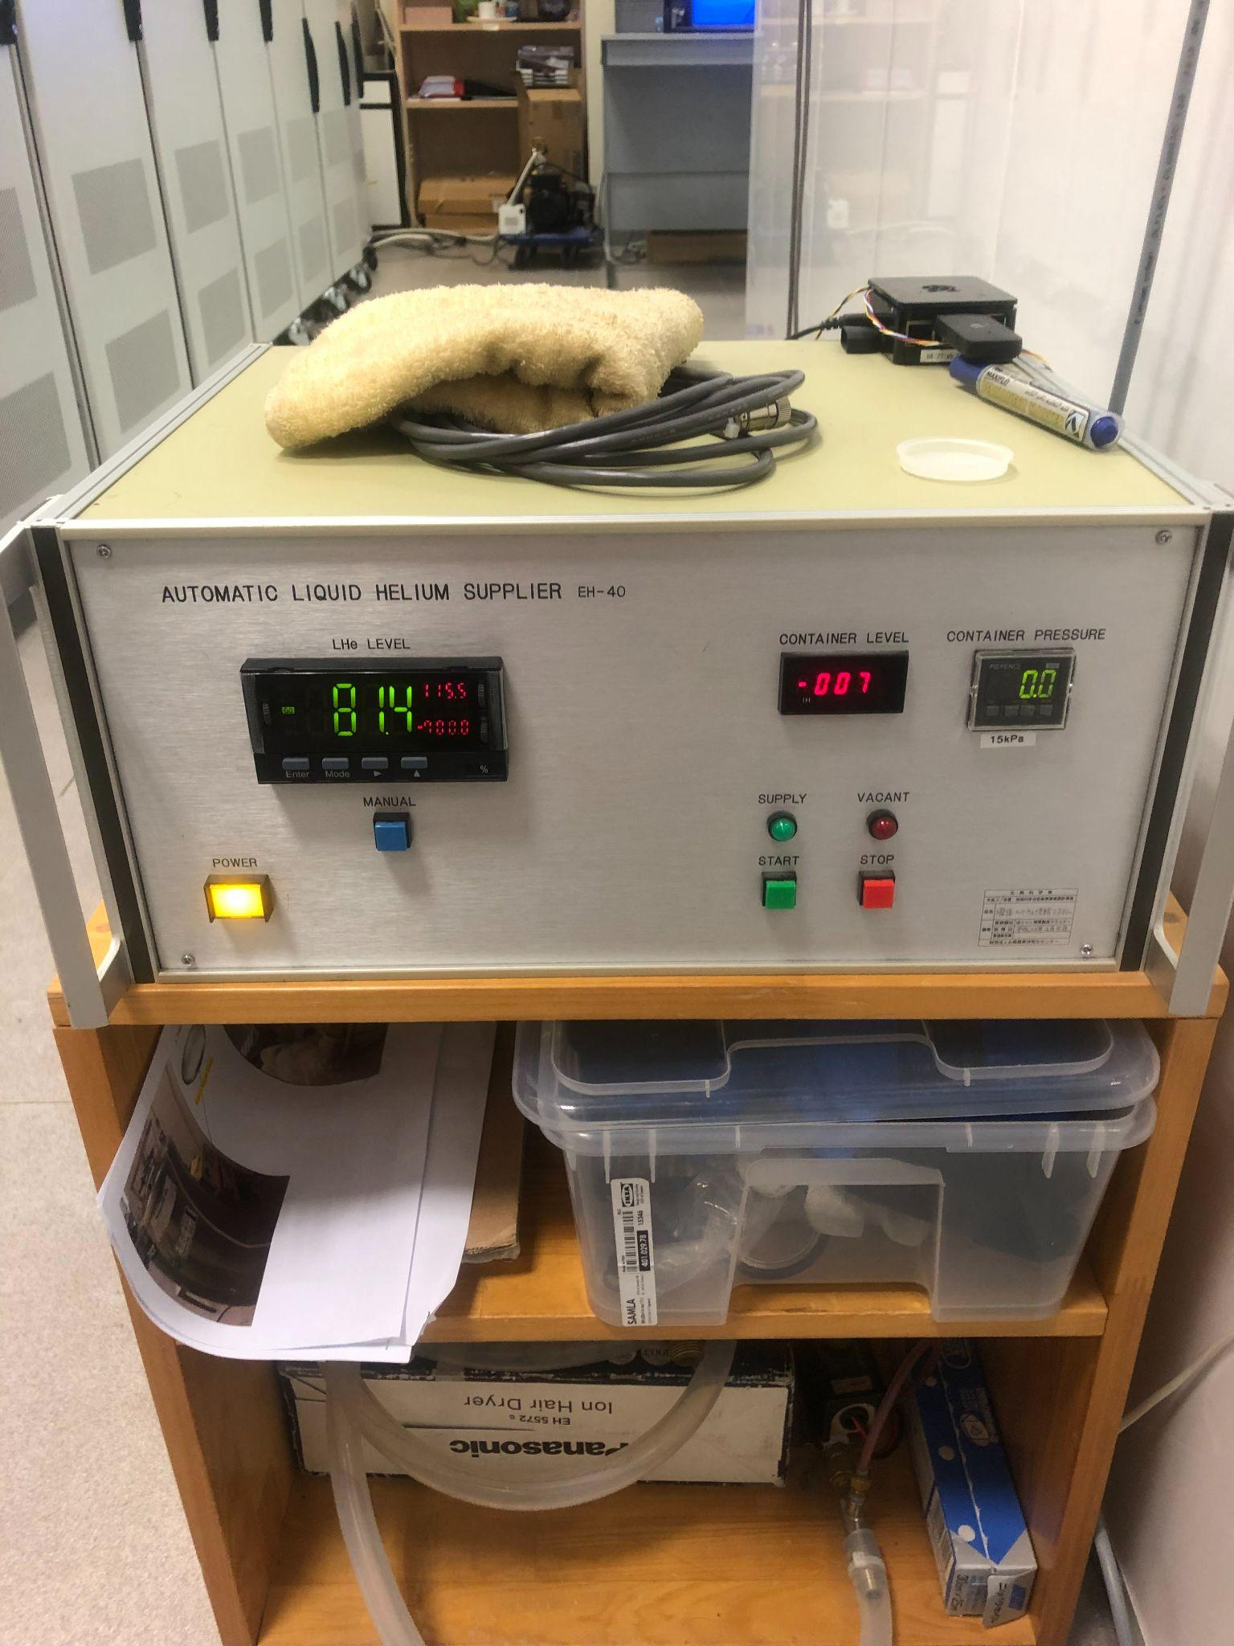

* Gives information about the levels of the liquid helium in the dewar
* The LHe Level should read between 0-100. 100 means the tank is completely full, 0 means the tank is completely empty (very very bad). If the heater is off, the number will be above 100, and it should go back down once the heater is turned back on.
* Check whenever in the lab, and if it seems to be emptying quicker than usual schedule a helium refill by contacting Osama ASAP.

### RECRUITING PARTICIPANTS

#### How to recruit

Technically, any communication we have with potential subjects must be approved by the IRB. That means posters, emails, social media posts, etc. The recruitment methods we have used in the past that have been (mostly) successful are:

* Posting an announcement to the Intranet
* Posting the study on SONA
* Hanging posters around public campus spaces
* Posting on the Saadiyat Swap Facebook group
* Emailing participants who have completed studies with us in the past
* For special speaker populations, having a point of contact to reach speakers directly (inside or outside of NYUAD) can be useful
  + Arabic adults: Meera al Kaabi at UAEU (m_alkaabi@uaeu.ac.ae)

#### Scheduling participants

* In order to make sure there are no scheduling conflicts for the MEG, we use a Google Calendar and the Core Labs calendar. Only MEG users and public safety have access to the GCal, while researchers from other groups at NYUAD have access to the Core Labs calendar.
  + Google Calendar: <https://calendar.google.com/calendar/u/0?cid=bnl1LmVkdV83Y2VlNDQyajZpaDdxaTIyN3JpNmM1aTVxOEBncm91cC5jYWxlbmRhci5nb29nbGUuY29t>
  + Core Labs:

<https://corelabs.abudhabi.nyu.edu/>

* It’s also useful to send a reminder email to participants the day before they are scheduled to remind them of time, location, not to wear metal, etc.

### RUNNING THE EXPERIMENT

#### Preparing paperwork: consent & participant’s information

Acquiring consent from participants is the most important first step*.* **This should be**

**done before any other step.**

* Make sure all the paperwork is filled out and signed by the participant prior to the experiment.
* Different labs use different consent forms and methods for filling them out. Make sure you have the correct forms for your lab!
* Also add your participants to your lab’s record keeping system so that you may refer back to their information later

#### Before participants arrive

* Check default settings on all equipment to make sure everything will run correctly. They should be identical to the following pictures.
  + FastScan PC

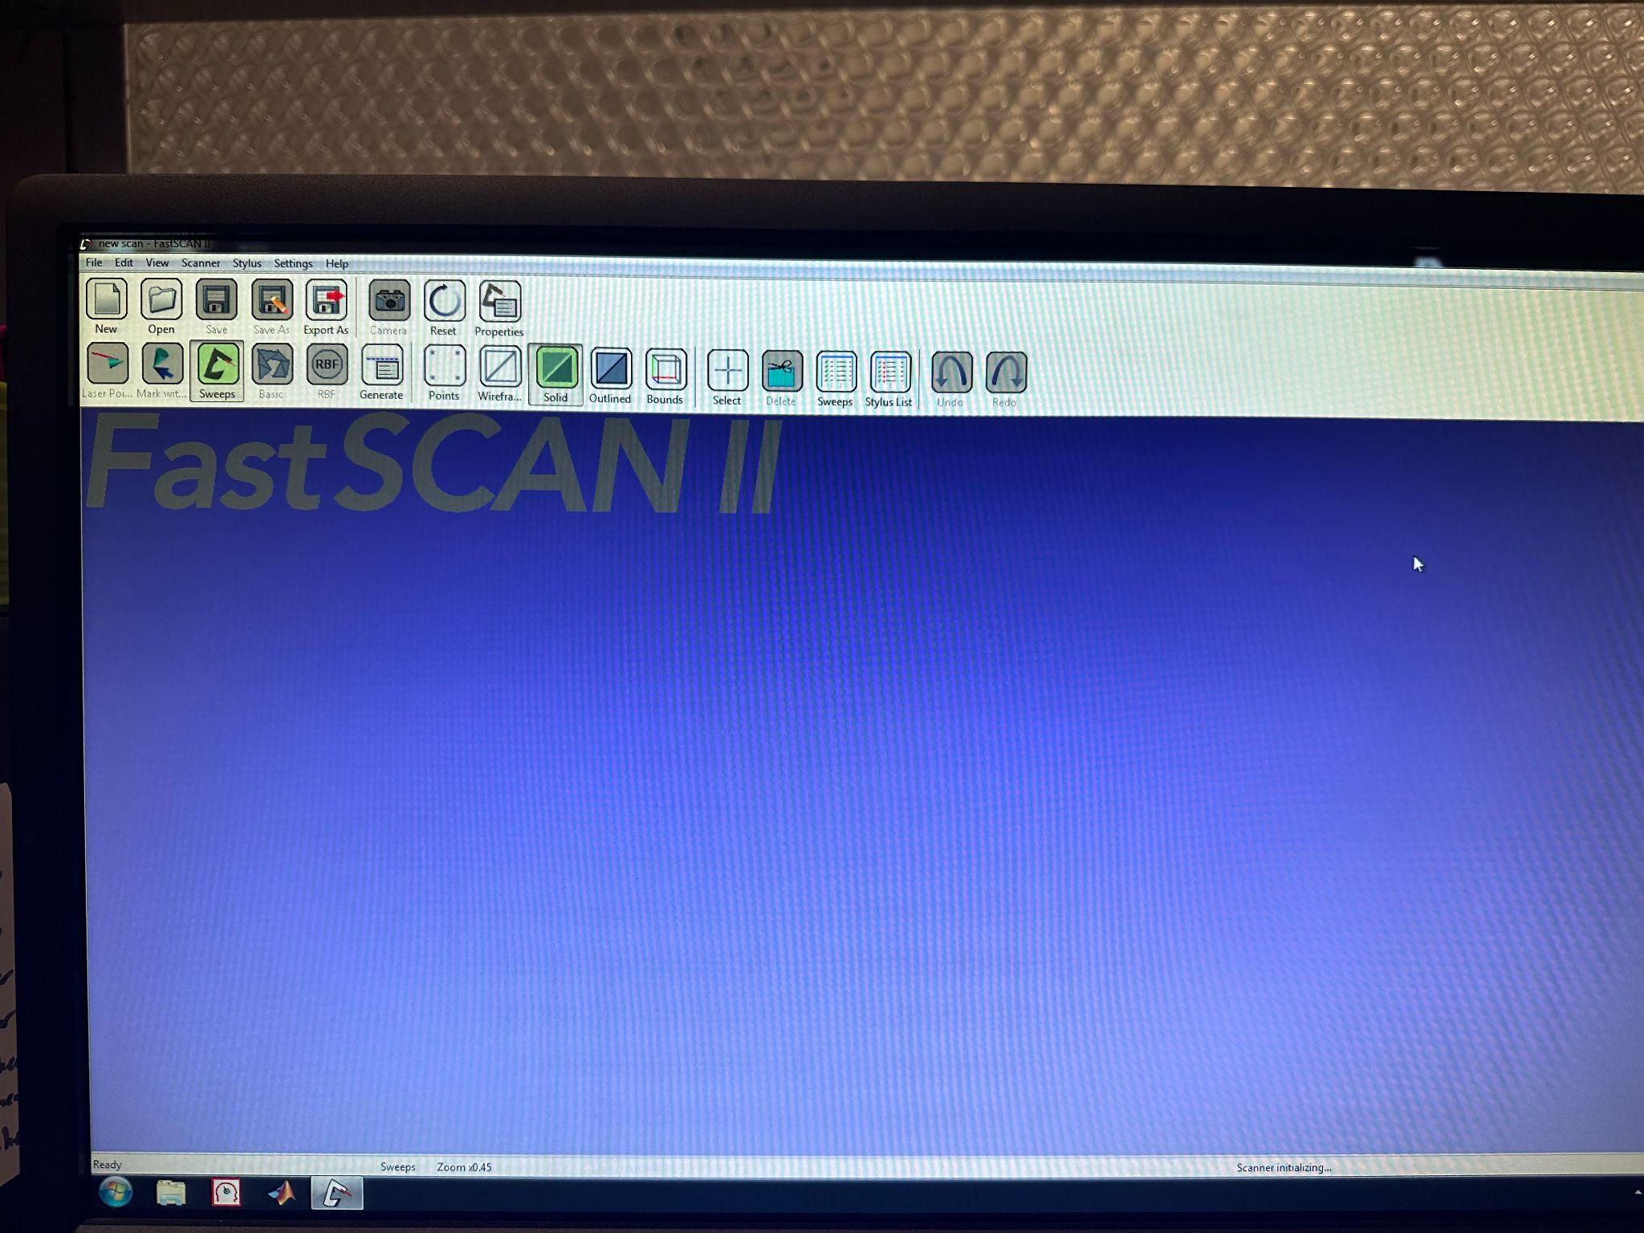

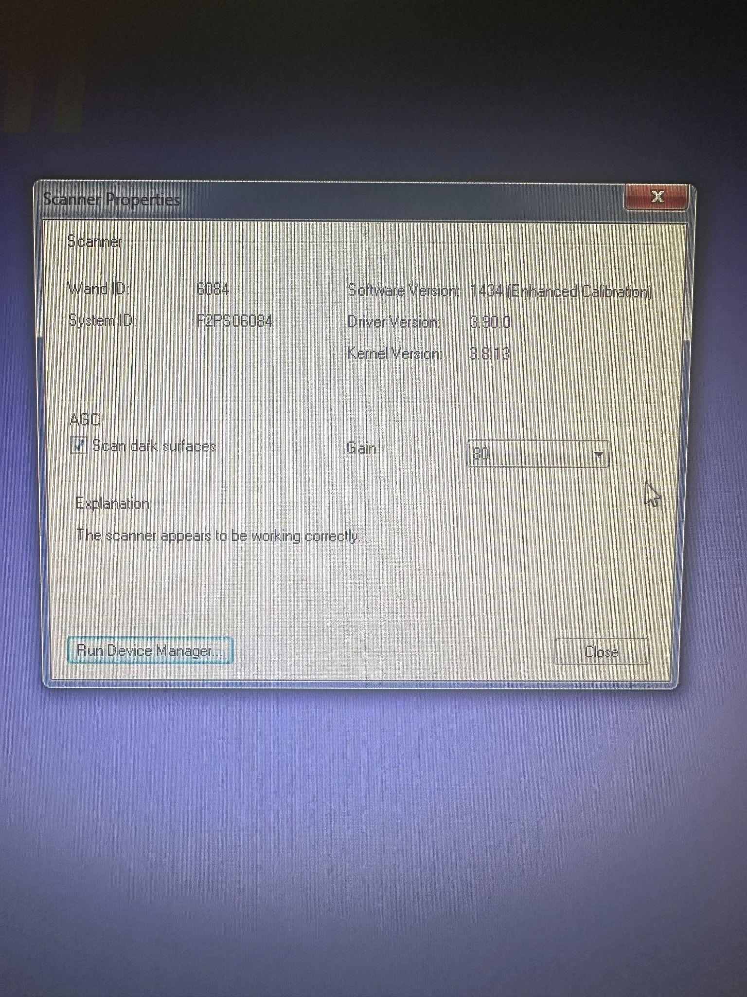

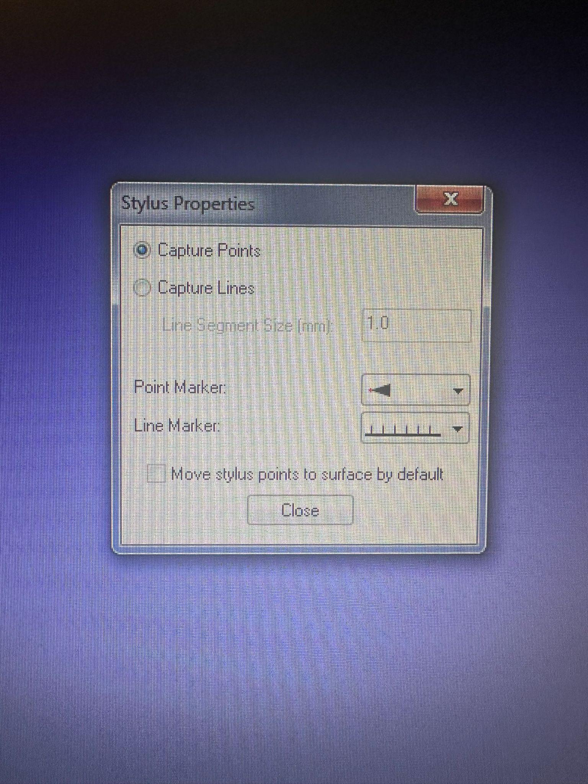

* + MEG PC

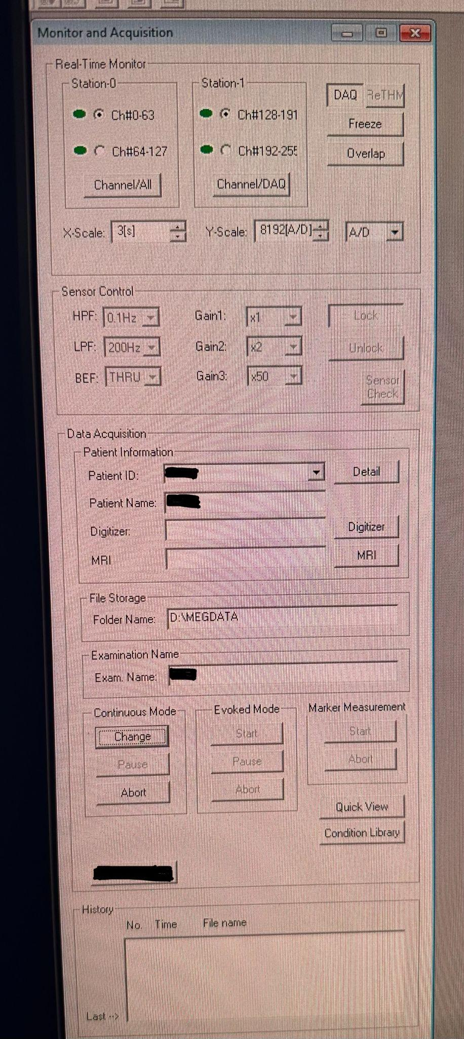

* + VPixx PC
    - - PROPixxCTRL and PROPixx options should appear in the 'General' section of the PyPixx GUI (if not, swithching off and on the Vpixx blue boxes worked in the past)
    - - PROPixxCTRL > Configuration > Restore Factory Power-On Settings
    - - PROPixxCTRL > Video Mode Configuration > C24
    - - PROPixx > Configuration > Sequencer: RGB 120 Hz
    - - PROPixx > Configuration > Calibration Selection: Normal
    - - PROPixx > Configuration > LED Intensity 100%
    - - PROPixx > Configuration > Ceiling Mount: unselected
    - - PROPixx > Configuration > Rear projection: selected
* Prepare the MSR
  + **Before opening the door, make sure the sensors are unlocked**
  + Turn the heater off on the back of the MSR (light on indicates the heater is on)

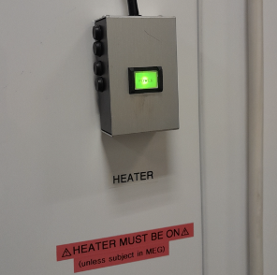

* + Put a bedsheet and pillowcase down
  + Pre-cut 10-15 pieces of tape to secure the marker coils to participant
  + Turn on the marker box.

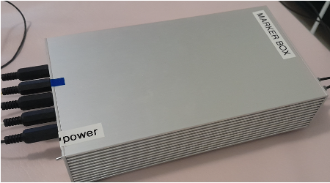

* Perform auto tuning of the MEG sensors:
  + Turn off the heater cable.
  + Make sure the trigger box ‘Source’ is on PC

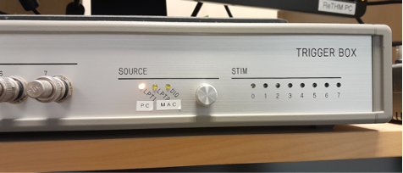

* + Turn on MSR lights.
  + Turn on the projector in MSR. The remote is kept next to the MSR, or you can do it via the VPixx PC.
  + Close and lock the MSR door.
  + On the MEG PC, on MEG160, from the menu “Acquire”, select “Auto tuning” then “OK”.
* Locate the file path to save your data in:
  + On the MEG PC, go into D:\MEGDATA, and in your lab’s folder and your experiment folder, create a new folder for the participant’s data with their subject number.
  + Copy the file path to that folder
* Perform empty room recording - this should be done to test that all experiment triggers, sensors, and electronics are working properly
  + Only needs to be done once per day
  + On MEG160, from the menu “Acquire”, select “MEG Measurement”
  + Double check default settings are correct
  + Patient ID: <projectname>_emptyroom_<data in ddmmyyyy>
  + Name: <projectname>_emptyroom
  + Foldername: D:\MEGDATA\<projectfolder>
  + Only lock the sensors **once the door is closed**
  + Take a 3-5 minute empty room recording once the sensors have stabilized.
  + The recording will save to folder you input
* Set up stimulus computer
  + (For the legacy system) If you have any stimulus presentation which is triggered by the participant speaking, you must connect the sound board to the Stim PC. To do this, unplug the red cord from the microphone driver output, and plug in the red end of the audio cable hanging on the Stim PC. Plug the black end of the audio cable into the microphone input on the front of the Stim PC. Be sure to unplug it again once the experiment is complete.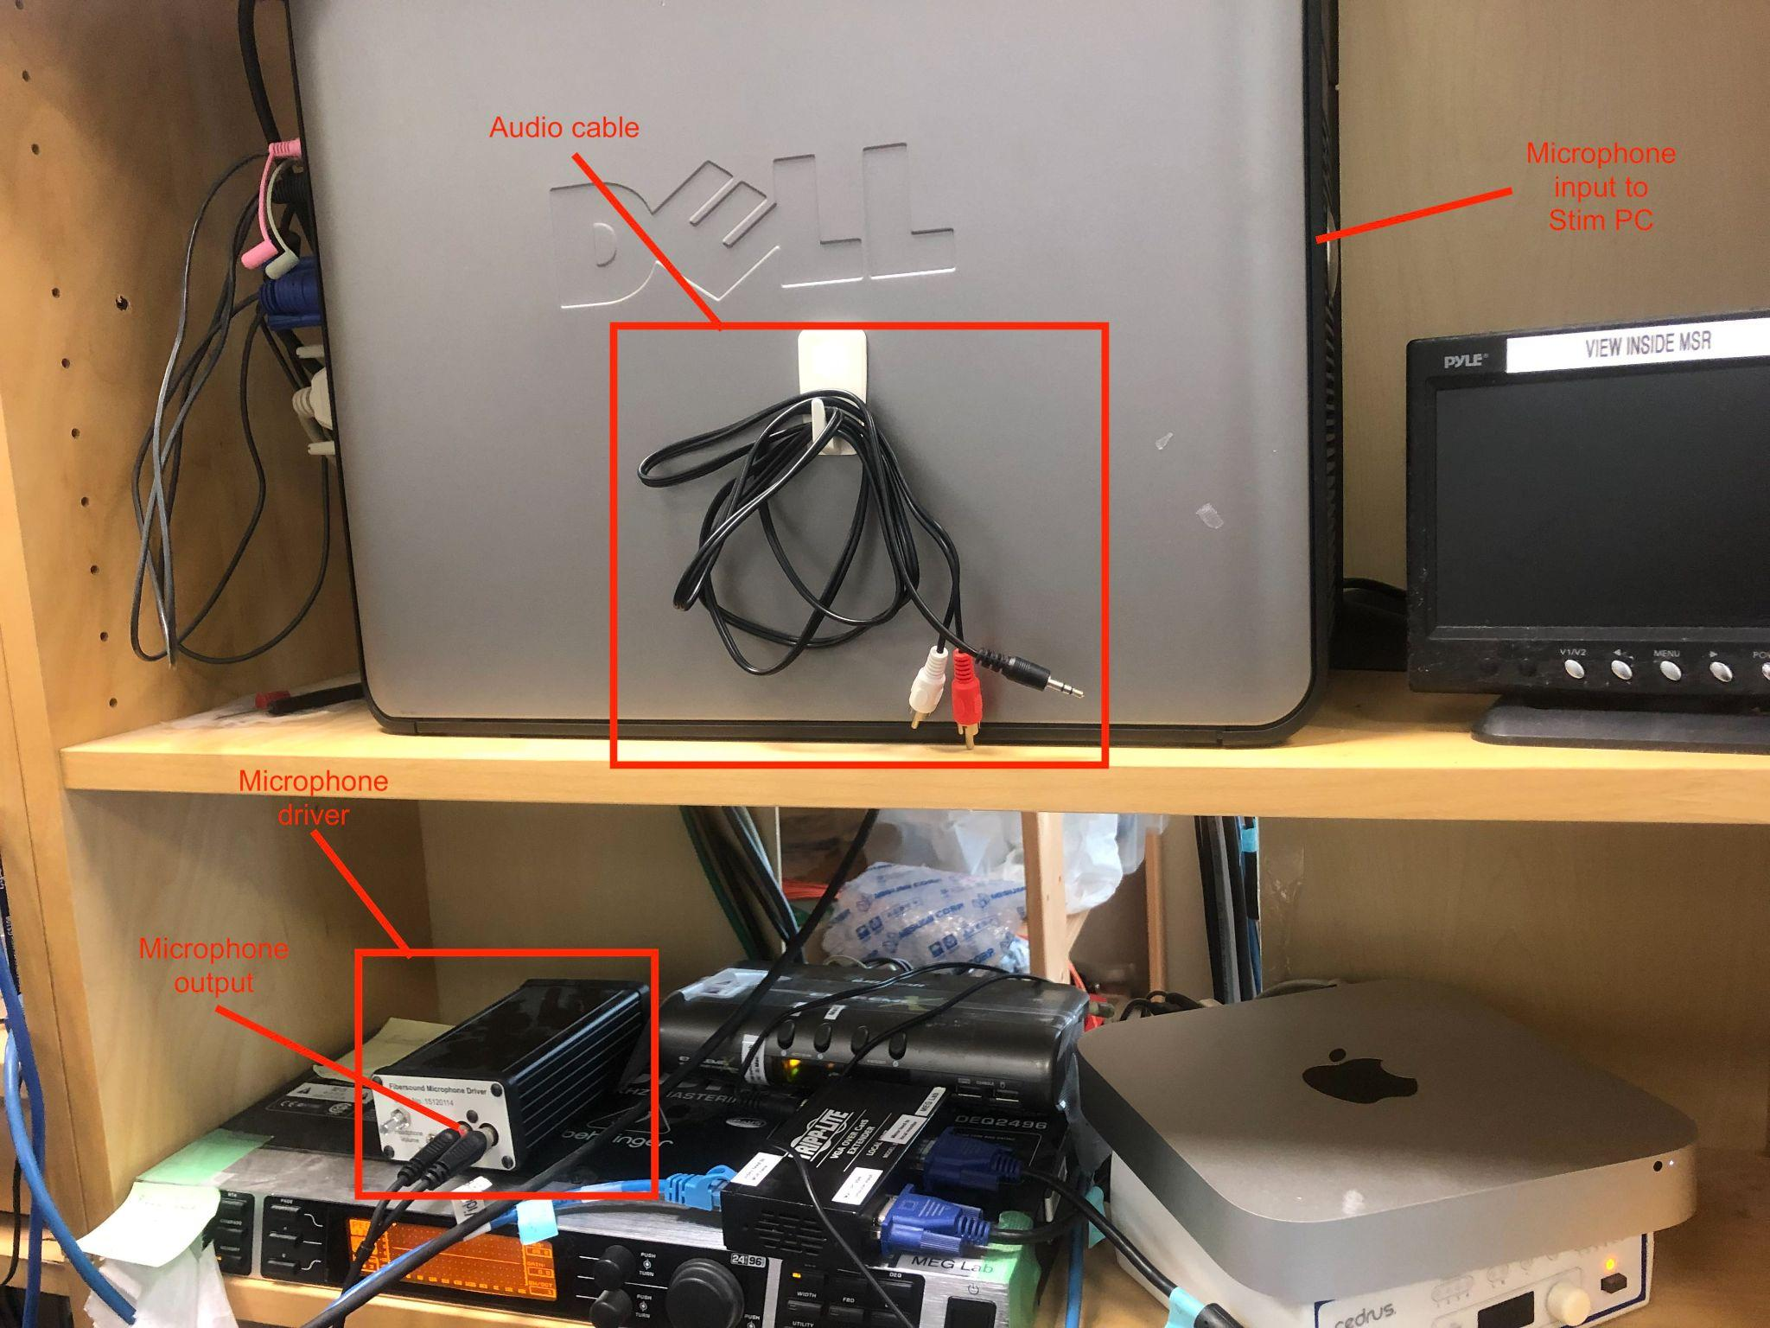
  + VPixx system
    - All three control boxes should be on (red light indicator)
    - Ensure that your experiment appears on the secondary monitor, either by extending or duplicating the display in the settings (whichever you need for your experiment to function properly)
    - Make sure that the keyboard volume is off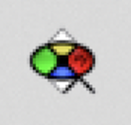
    - Open PyPixx , make sure ‘Ceiling Mount’ is unselected, and ‘Rear Projection’ is selected
    - Select ‘Wake ProPixx’ to turn on the projector
* Prepare scripts on the stimulus computer
  + Matlab
    - Do NOT open matlab clicking on the matlab icon
    - Open matlab with double click on the task script
    - Should be run by EXTENDING the display
  + PsychoPy
    - Must use Pixel Trigger mode (can turn on with PyPixx GUI or using code snippet in experiment script)
    - Open by clicking on your .psyexp file
    - Should be run by DUPLICATING the display
* Turn on monitor for MSR camera.
* Turn on eye-tracker by typing ‘t’ to initiate the program.
* Prepare Fastscan computer
  + Make sure that FastScan device is off (the flat box next to the monitor)

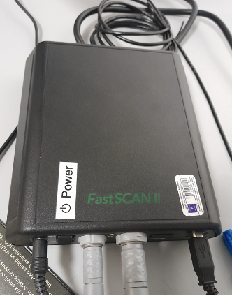

* + Turn on the computer and launch FastScanII program
  + Turn on the FastSan device once the computer is on and FastScanII is open
* Turn on airplane mode on phone (can be done whenever before recording).
  + Phone ringing will introduce a significant amount of noise and will likely saturate the channels (the channels will be “dead” for that session).
  + In which case, before your next recording session you will need to tune the sensors again (see the steps on performing auto tuning).

#### Digitizing head shape

Starting at this step, quality control becomes crucial. Head shape digitisation sets up the *head coordinate frame*, which at the stage of co-registration aligns (hopefully!) with the MRI coordinate frame (for more, read on [on MNE’s documentation](https://mne.tools/stable/auto_tutorials/source-modeling/plot_source_alignment.html#understanding-coordinate-frames); see also the [NIH MEG](https://megcore.nih.gov/index.php/User_Information) website). The goal here is to create a surface onto which the MRI can map; having some surfaces containing the fiducial/anatomical landmarks helps with this mapping process.

1. Let the participant put on a swim cap; make sure the cap is as smooth as possible.
   * If you’re using FastScan II, the medium shades work best (i.e. pink or royal blue caps). If you’re using the old FastScan, light blue caps work best.
   * For child participants: if the swim caps are too big and end up covering most of the forehead, push it back just enough to expose the forehead, and roll the extra fabric that’s on the back of their neck into the cap
2. Use a washable marker to make five points on the participants head:
   * Use the “T” template, with the line aligning the participant’s nasion
   * Then mark the head position indicator points through the holes
   * Also mark the left and right pre-auriculars (1cm anterior to the left and right tragi)

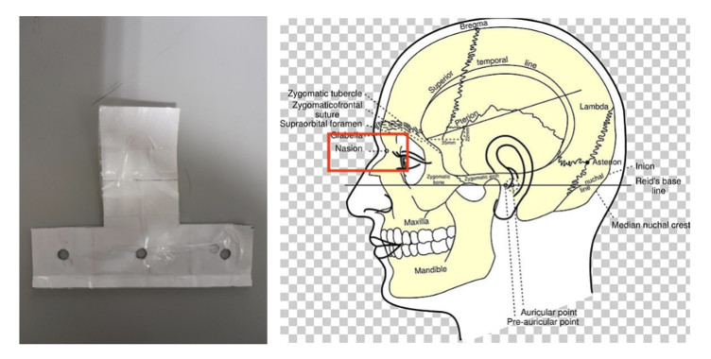

1. Help them put on the neck brace (place tissue at the jaw if needed, as shown in picture). Make sure that it will stay stable throughout the head scan procedure.
   * Place a tissue over the area closest to the mouth on the neck brace for sanitary purposes.
   * For child participants: depending on how old the participant is, you might have to make them try out different neck braces to see which one fits! The adult one fits fine, but it takes up a huge chunk of the back of their head

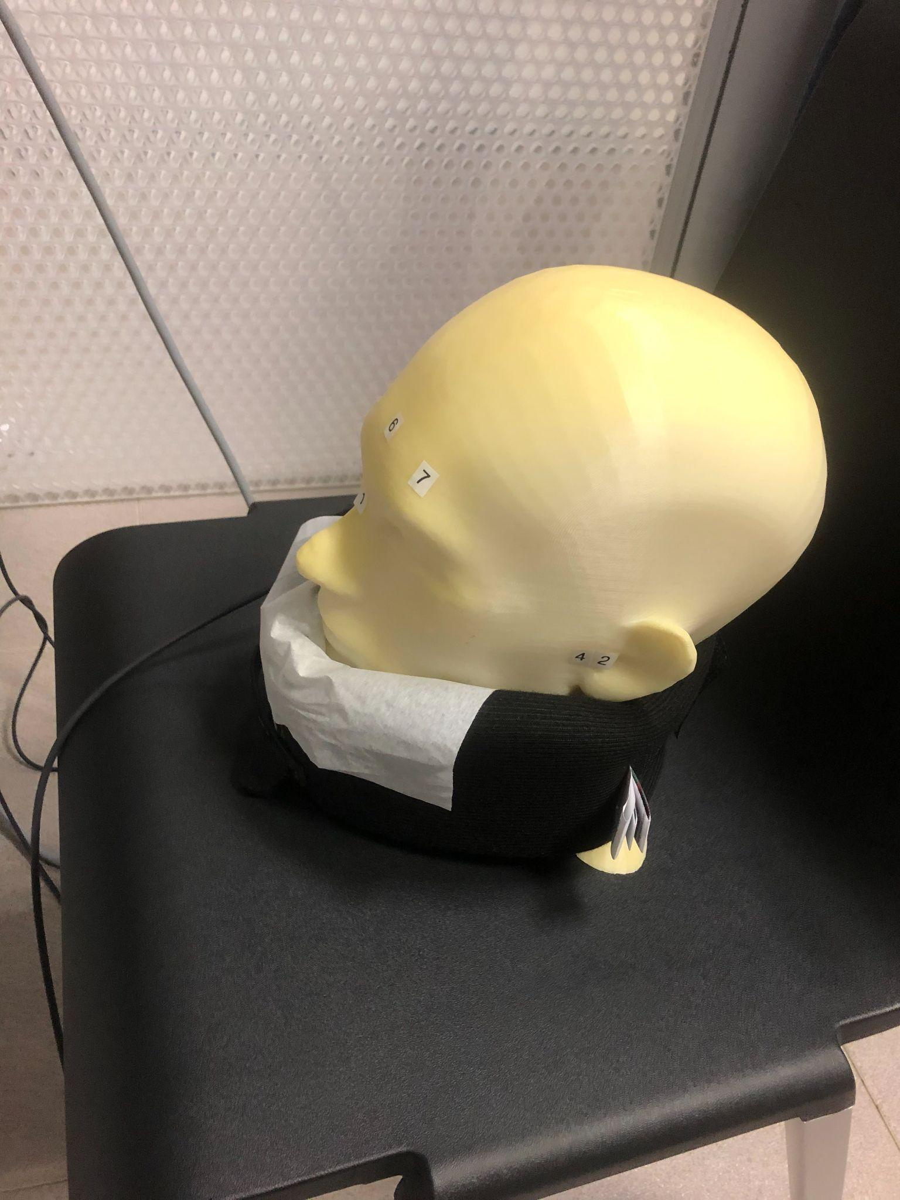

1. Once FastScan is finished initializing (indicated at the bottom of the software UI):
   * Point the laser gun at the stationary point (the box on the ring you place around the neck) with a half-click, followed by a full click.
   * When you initialize the Fastscan, the scanner is automatically set to do sweeps rather than points (the laser is a line). To do the initialization with a point, click ‘Laser Point’ in the GUI, and switch back to ‘Sweeps’ before beginning the head shape.
2. At a minimum, you need all of the cap surface plus surfaces on which the fiducial points fall.
3. I suggest:
   * Avoiding making overlapping sweeps, as they increase the likelihood of creating uneven basic surfaces.
   * Avoiding making sweeps that covers face *and* cap; instead, sweep these two parts separately.
   * Making sweeps for head and face separately.
   * Keep a consistent distance between the head and scanner. You do not want to be too close or too far from the head, and varying the distance too much could cause the surfaces to be disjoint. The photo demonstrates an appropriate distance from scanner to head.

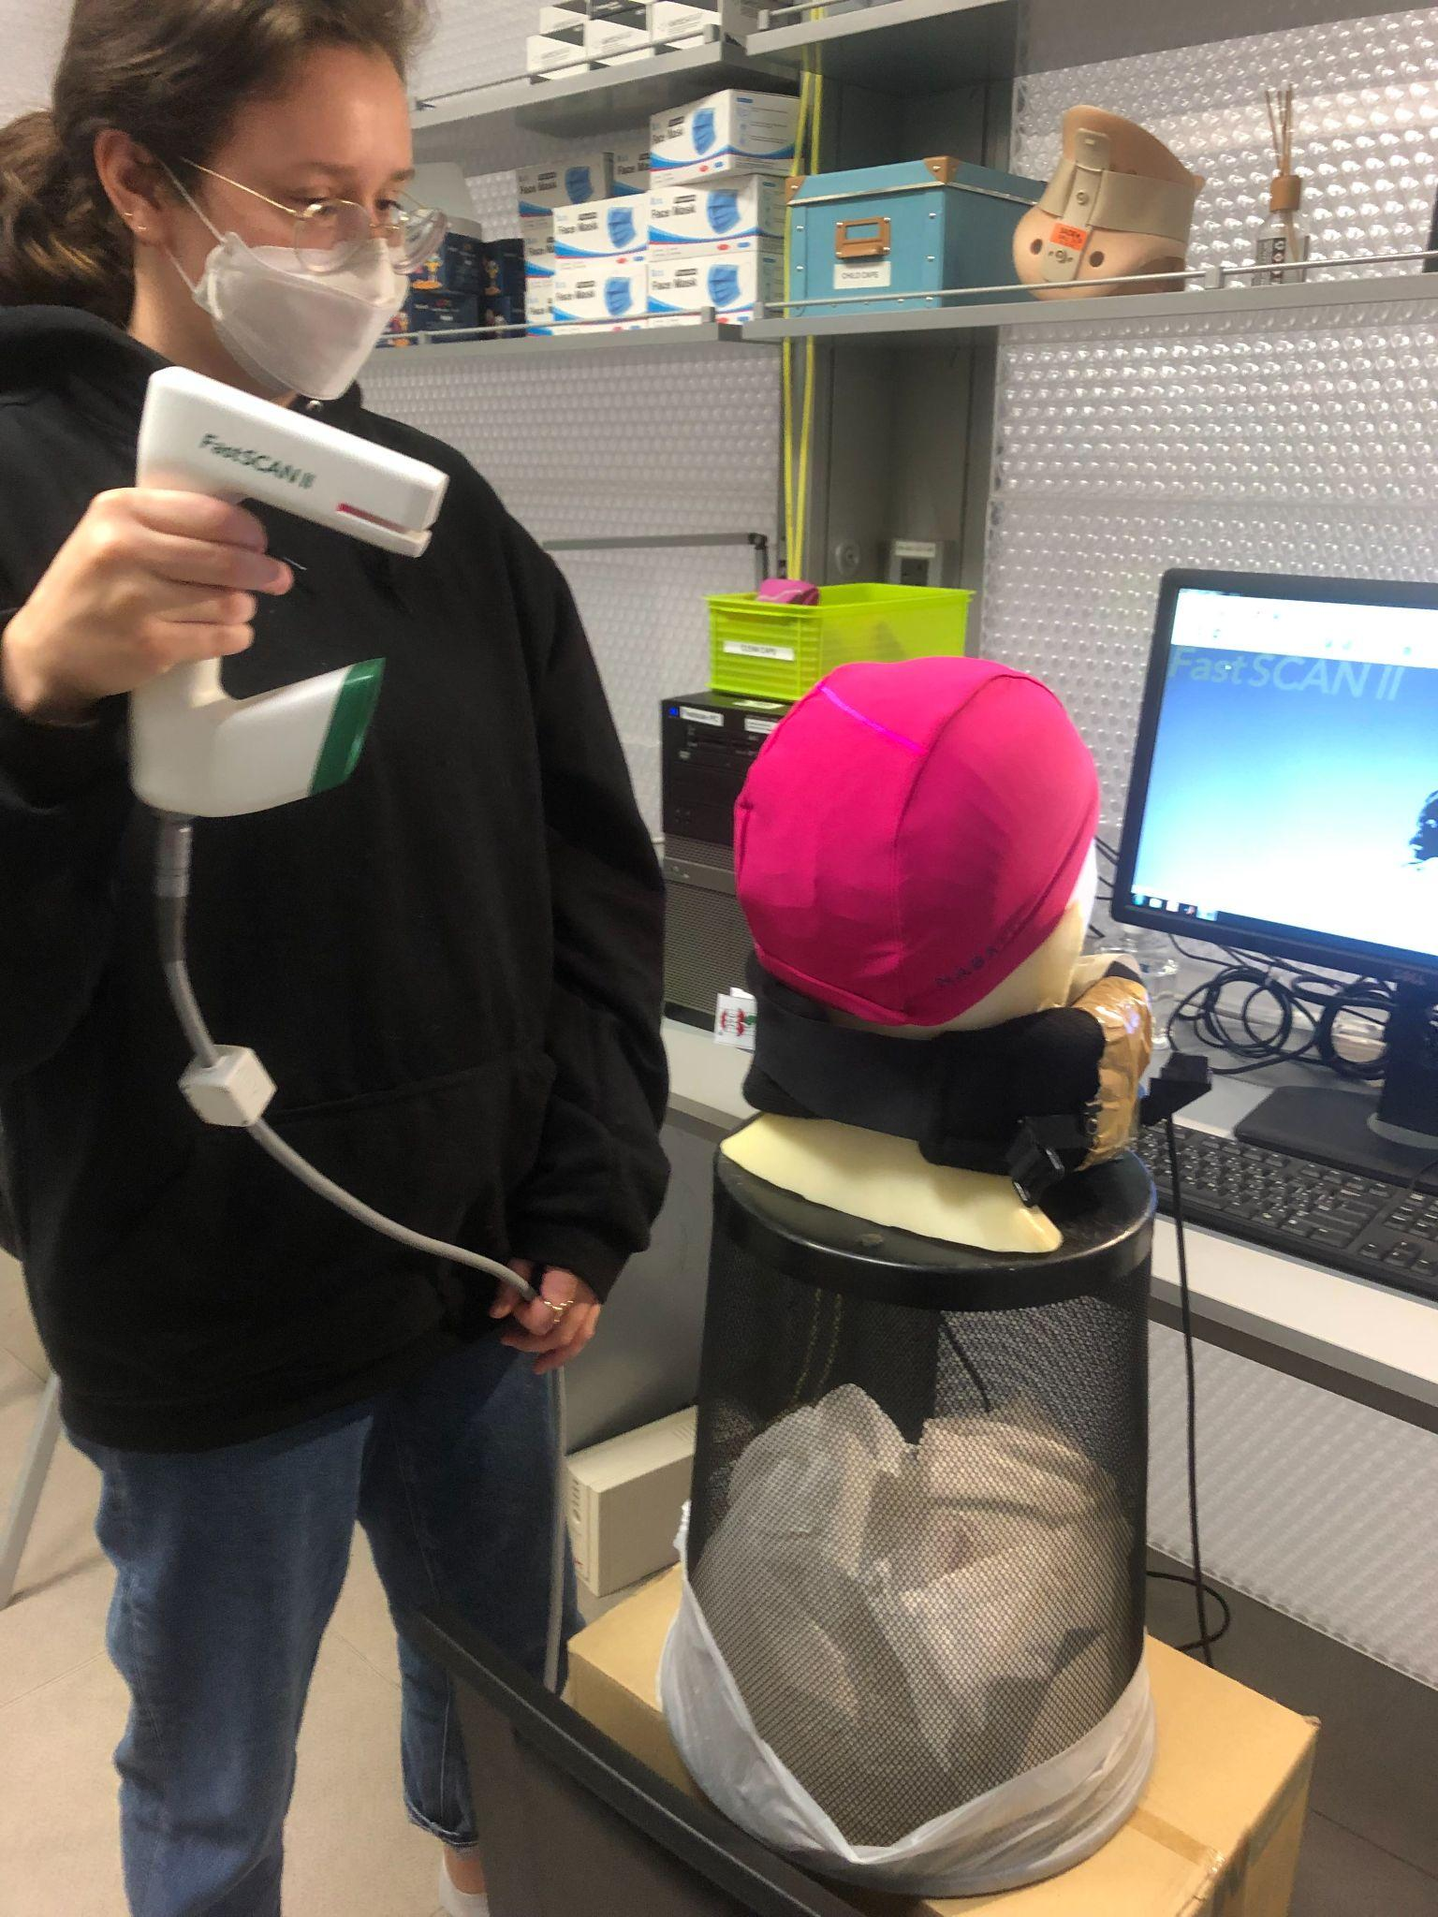

1. After sweeps, switch to Laser Points and click on Stylus List for points options. Close the flap down on the laser gun and start registering the fiducial points following this order:
   * Nasion - between eye-brows (not marked)
   * (Participant's) left tragus - cartilage of left ear (not marked)
   * Right tragus - cartilage of right ear (not marked)
   * Left marker - marked left ear
   * Right marker - marked right ear
   * Center forehead - marked center forehead point
   * Left forehead - marked left forehead point
   * Right forehead - marked right forehead point

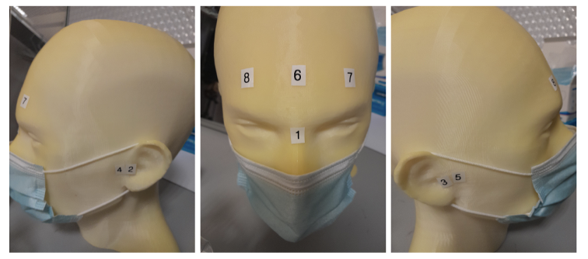

1. When you are finished with the scan and before the participant stands up, be sure to return the scanner and box to the foam holder on the table, and make sure none of the cords are on the floor. The long cords create a tripping hazard, and the scanner can be damaged if it falls from the table.

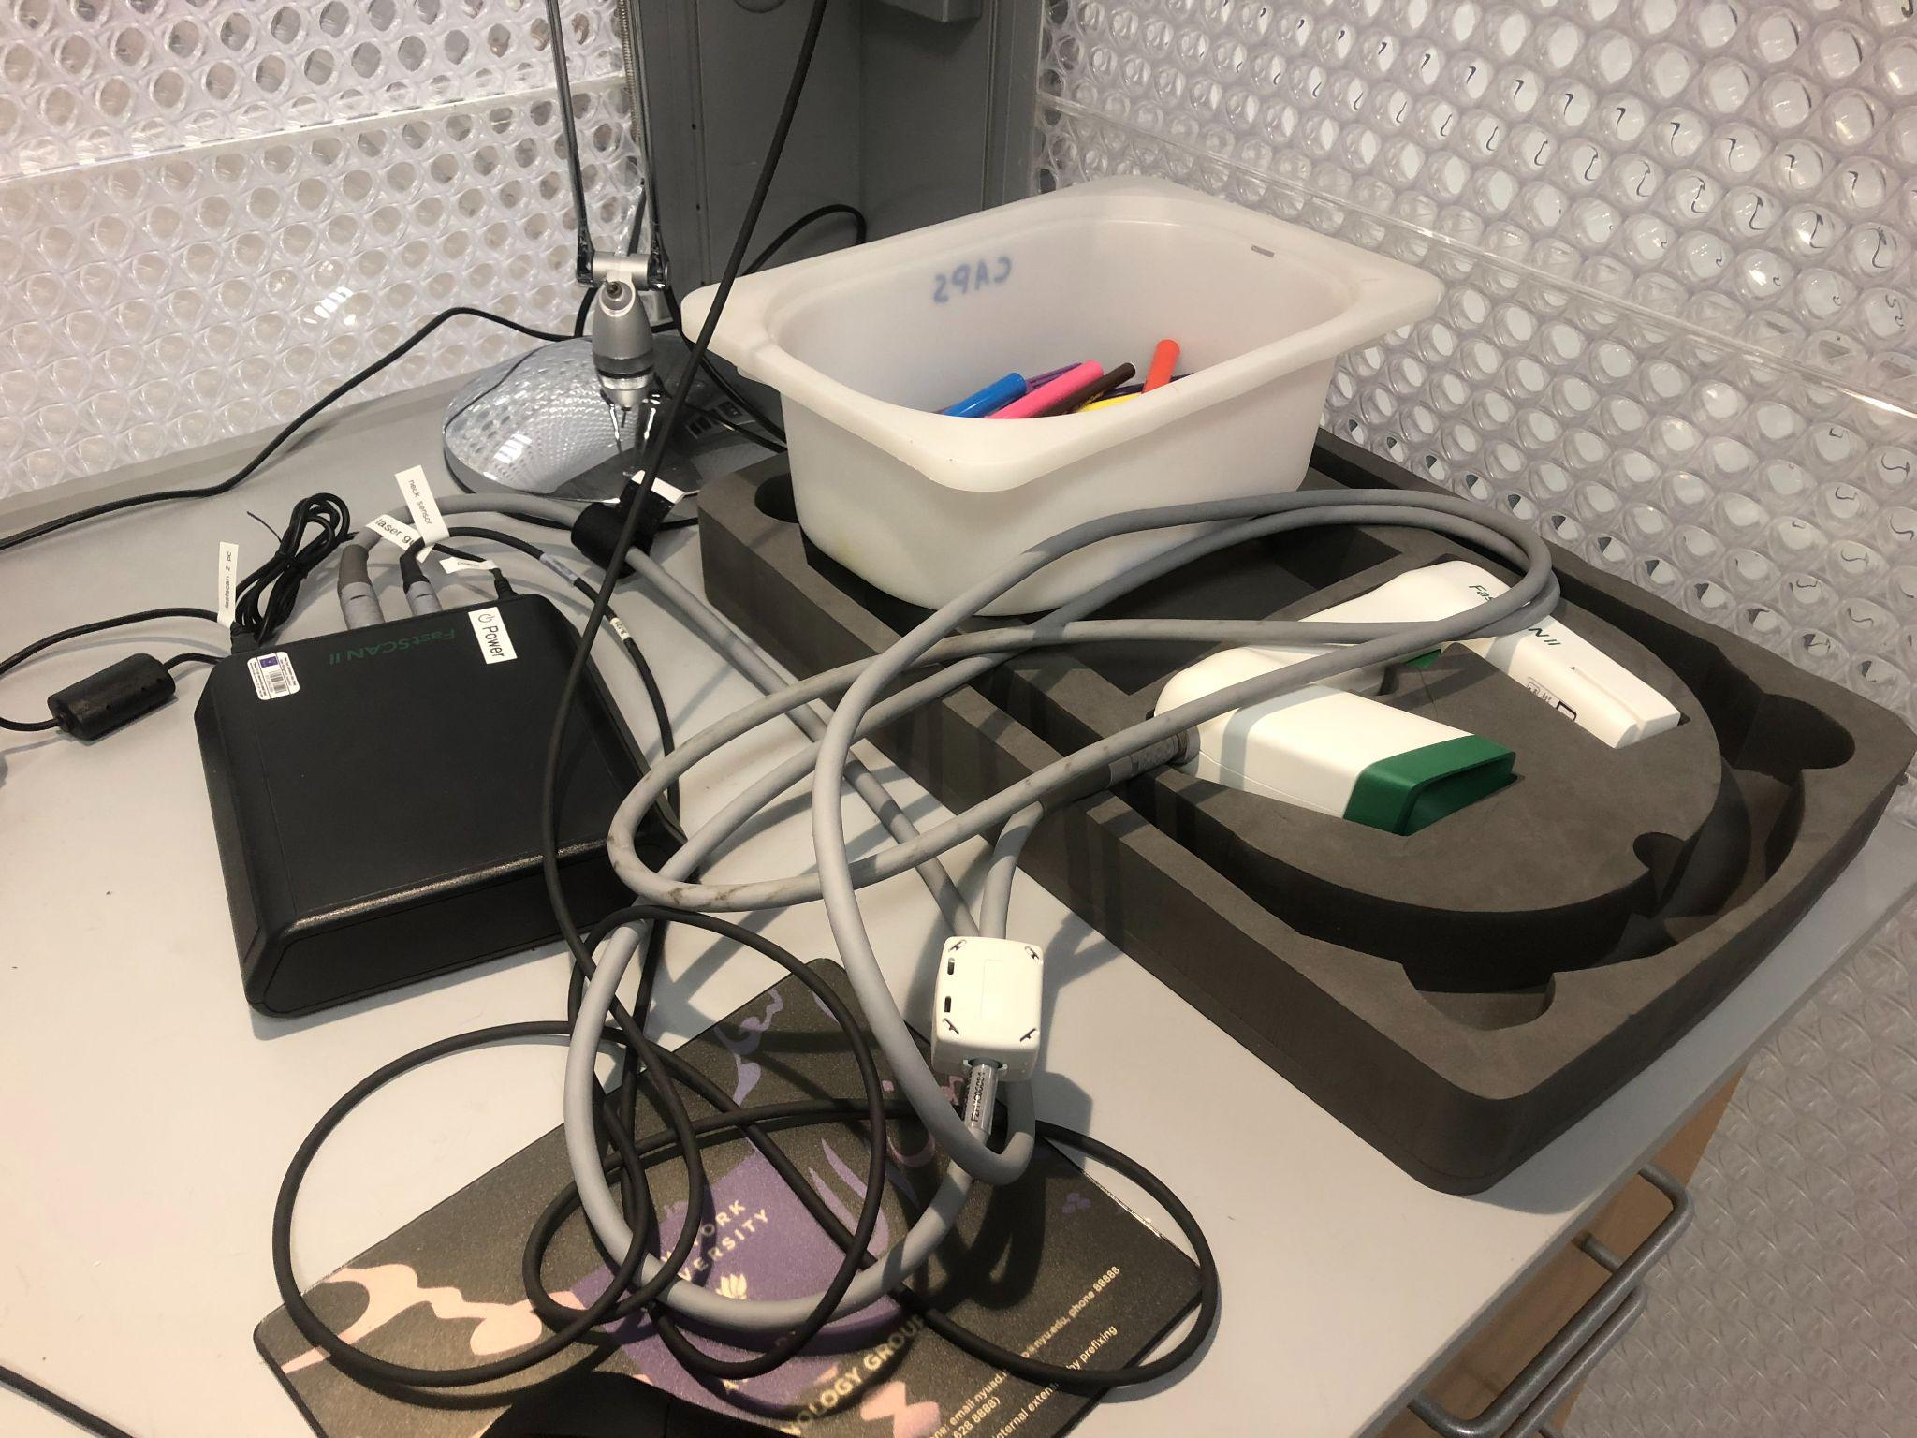

| At this point, your participant is good to go to the next step, which is the MEG experiment part. The following steps are to clean up the digitisation for coregistration. |
| --- |

1. Save the file as “SubjectID_ExperimentName_Date.”
2. “Select” bits that you want to remove then press “Delete”.
3. Edit -- Generate surface -- Apply basic surface
   * Make sure the basic surface has less than 10,000 points in it otherwise MNE coregistration will not work.
   * To decimate the surface, click Generate > Surface Simplification = 0.10 > Apply (Basic Surface)
4. After applying the Basic Surface algorithm, examine for any stray sweeps that affect the head shape drastically and remove those.
5. File -- Export -- Basic surface.
6. Save the **.fsn** file, as well as both sweeps and points by appending ‘_basic’ and ‘_points’ to each respective file.

#### Preparing subject in MSR

Before entering the MSR subjects must remove any metal from their person. There are no known risks associated with MEG recordings. Although wearing metal objects while in the MSR is not harmful to the individual, bringing metallic or magnetic objects into the MSR causes interference and high noise levels in the recording. Here are common everyday items that may introduce noise:

* Bras with metal clips, clasps, snaps or under wires (even some plastic clasps or rings do have metal under the coating so can also introduce noise to the recordings).
* Makeup - mascara, eye liner, eye shadow
* Clothing containing metallic shiny threads or glitter
* Metal on clothing i.e., metal buttons, snaps or trimming (zippers and buttons on jeans are usually ok)
* Belts
* Keys
* Watches
* Rings or other jewelry
* Coins
* Eyeglasses (MEG-Safe plastic eyewear can be found in the participant preparation room, in a large plastic box labeled “*mediglasses*”).
* Cell phones
* Pagers
* Credit Cards
* Small metal objects such as hair pins, paper clips, safety pins, etc.
* …

It can be a good idea to stand with the participant before entering the MSR and slowly work your way down the body from head to toe asking if there is any metal on that part of the body.

Additionally, everyone entering the MSR must also remove their shoes.

It is recommended that participants are screened and given instructions before arriving for testing. However, if subjects arrive with metal on their clothing that can not be easily removed, they may be issued non-magnetic hospital clothing which will be provided by staff.

* Place the participant in the MSR, and make sure that they are comfortable. To begin they should sit on the side of the bed nearest to the small table.
* Place with tape the head position indicator coils on the marker points.
  + Bring the forehead markers over the top of the head so the wires are not in the participant’s face, as shown in the photo.

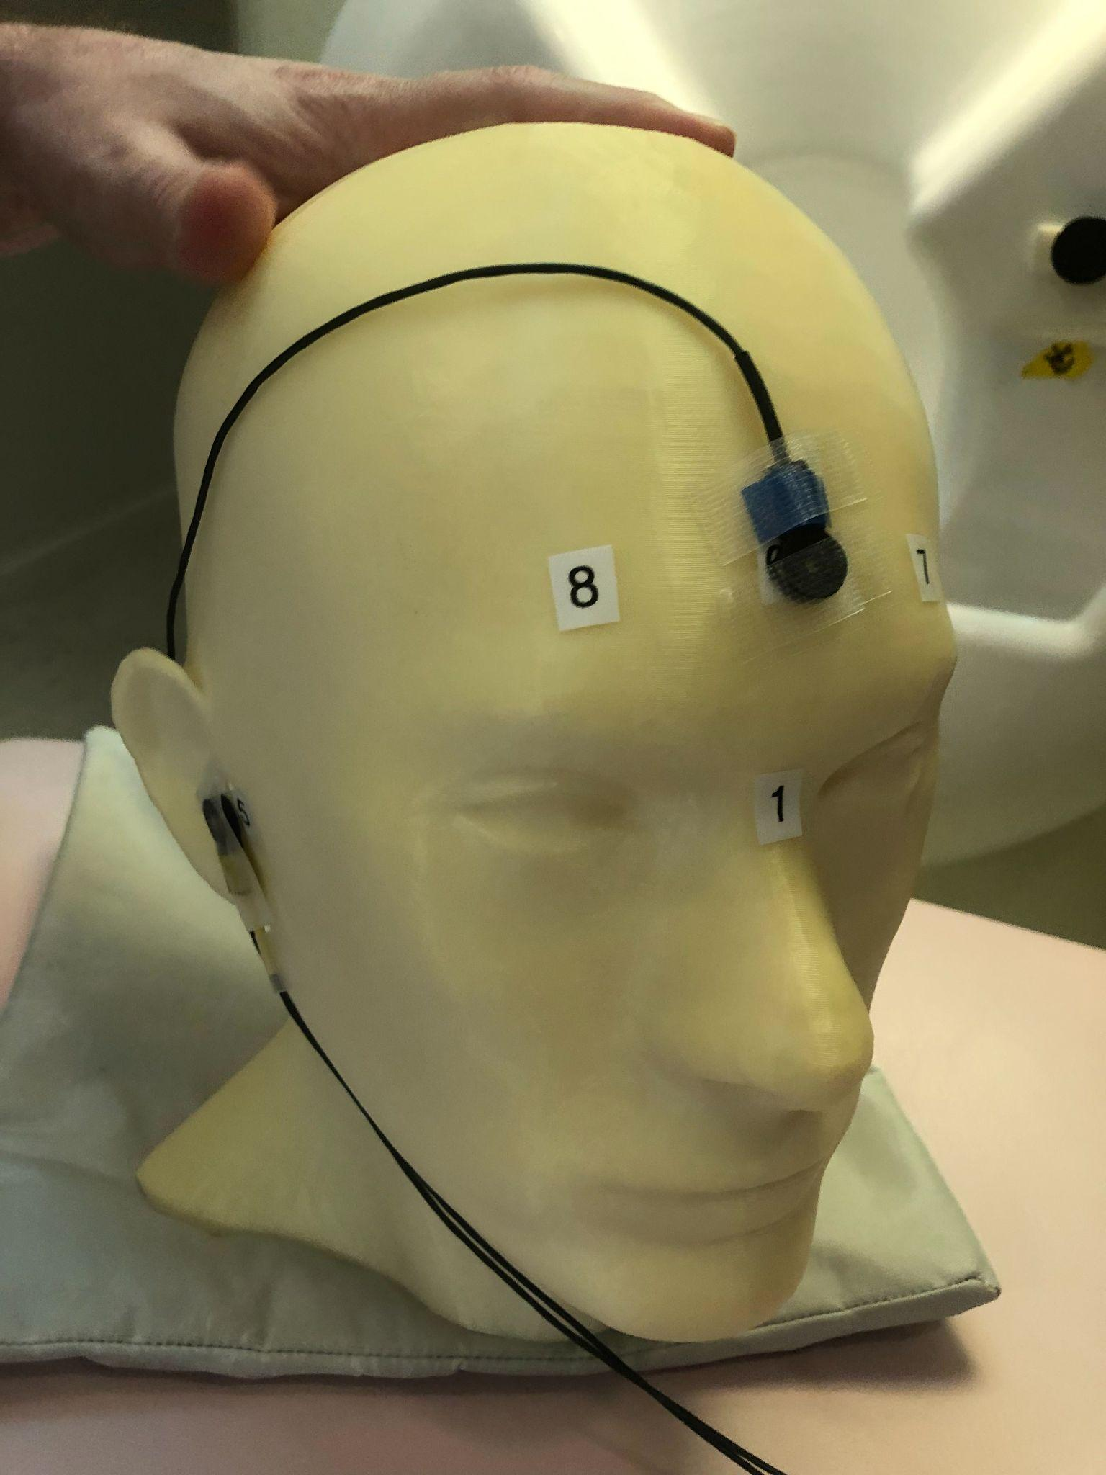

* + The ear markers can be difficult to attach securely. It is recommended not to loop the wires behind the ears as that can cause them to deteriorate over time. Instead use a vertical piece of tape over the sensor and an additional one horizontally across the wire to secure in front of the ears, as shown in the photo.

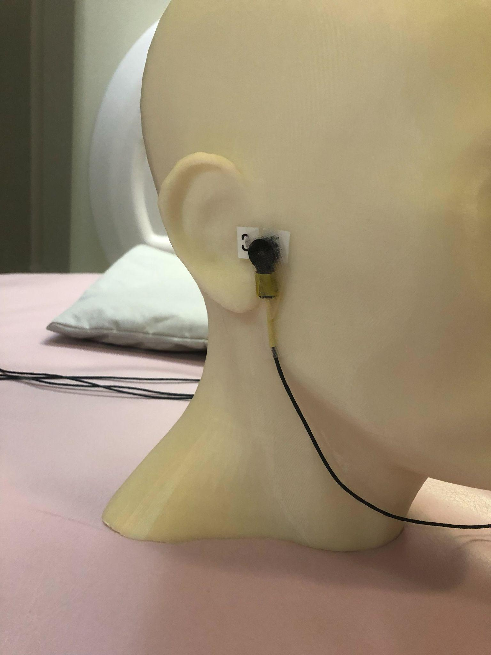

* Also make sure that the earphones are in place.
  + If the foam earphones are bending because the wires pull on them, you can trim the black plastic portion.
  + For child participants: if the earphones are too big & don’t fit in their ears, try trimming the soft pink foam that’s around the black tube to make the whole earpiece smaller
* Assist the participant with the wires while they move into the helmet. They should move as far back as possible, until they can feel the helmet on the top of their head.
* If there is a lot of extra room around the participant’s head, place the bubble wrap burritos on the sides of the participant’s head as shown in the photo. This will help to keep their head still as well as keeping the ear marker coils against the head if the tape fails. You may also want to put tissues around the foam for sanitary purposes.

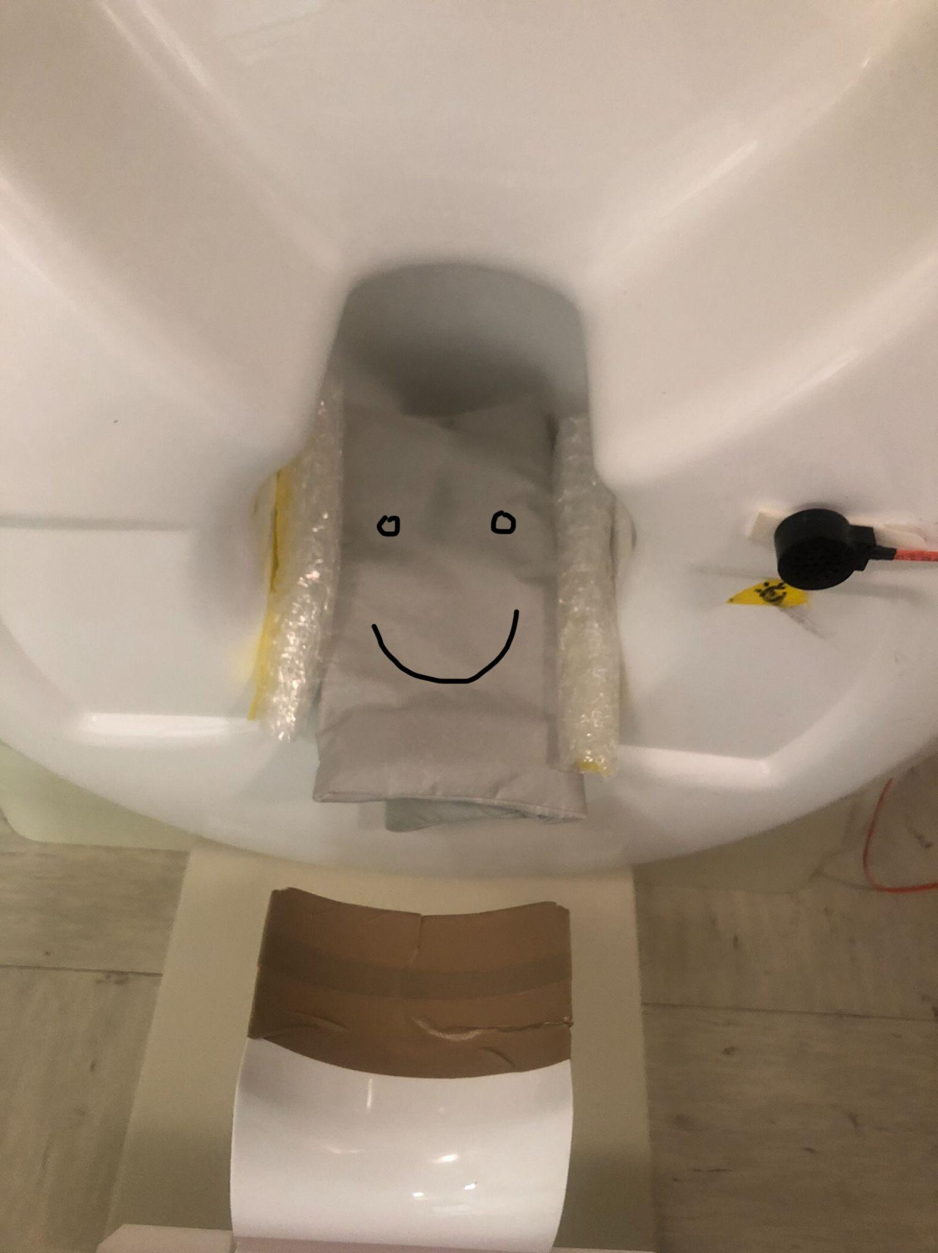

* Provide them with the triangle pillow under their knees for back support.
* If it is especially cold in the MSR, you may want to give them a blanket as well.
* Provide them with button box as required.
* Tape any loose wires for the markers and button boxes to the mattress.
* Close and lock the MSR doors.

| **NOTE**: When (metal) noise does show up in the recording after locking the sensors, you’ll need to figure out what is causing the noise. After that, the sensors might need to be autotuned again with the room empty and the door shut. |
| --- |

#### 

#### Check sensors, set parameters

On MEG160, one can set up online filters, input participant’s ID as well as specify where the data is saved once acquired.

* In our lab, we typically apply an online **high-pass filter at 0.1Hz** and a **low-pass filter at 200Hz**.
  + Only frequency bands between 0.1-200 Hz are recorded.
  + Also called a **band-pass filter of 0.1-200 Hz**.
* We also apply a **band elimination filter (BEM) at 60 Hz**, which removes the frequency band of 60 Hz from the recording.
* Gains:
  + The input gain setting next to a filter amplifies the signal sampled before the filter, while the output gain amplifies the signal after the filter.
  + They apparently should sum up to 100.
* **Trigger box**: Silver located on shelf above MEG system monitor.
  + Make sure it’s set to encode the triggers from the right operating system: if you’re using the legacy stimulus Mac, turn the knob to “Mac”; if you’re using the legacy stimulus PC or the VPixx PC, turn the knob to “PC”.

You can change the view of the sensors from individual channels to overlay by selecting the ‘Overlay’ option on MEG160. This can make seeing events (as well as some noise patterns) clearer.

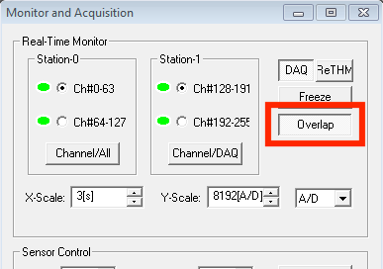

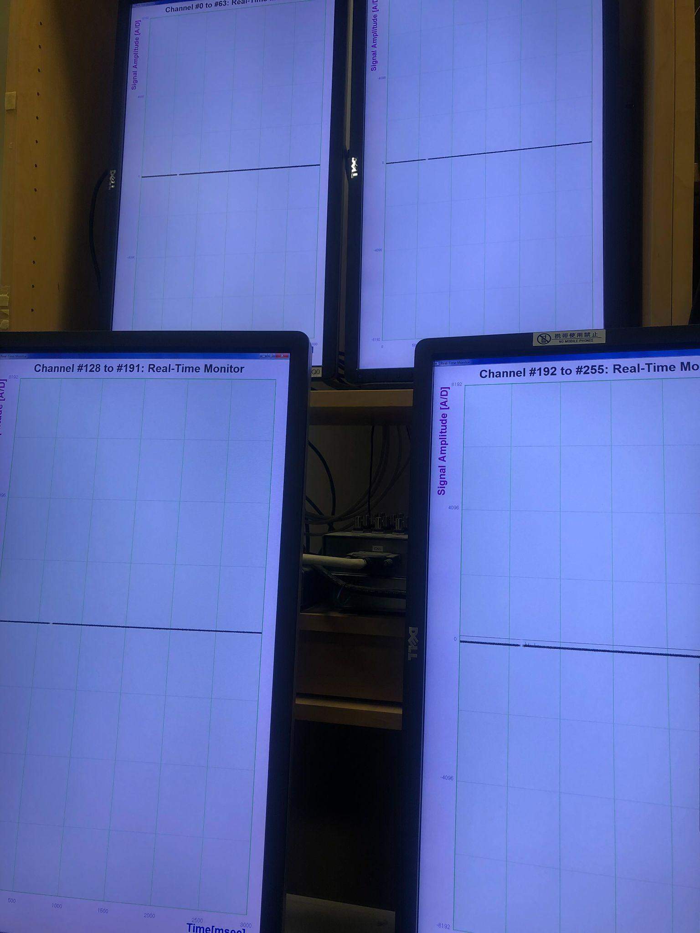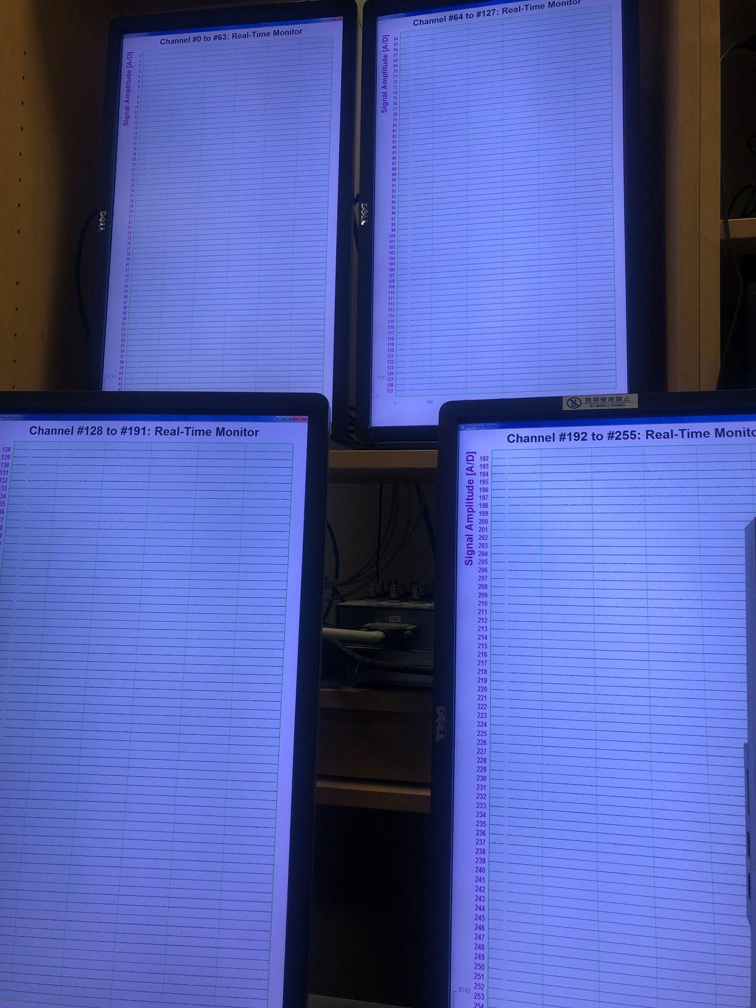

If there are noisy sensors that will be excluded from data analysis, you can exclude them from the sensor view. (They will still be recorded, however.) Select ‘Channel/All’ to select which sensors to exclude. If you want to use the preselected set of channels which are generally well-behaved, select ‘MEG Set1’ from the channel selection window.

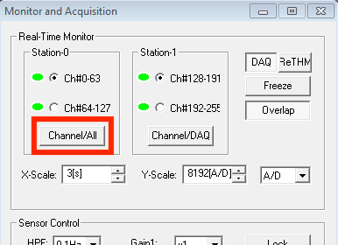

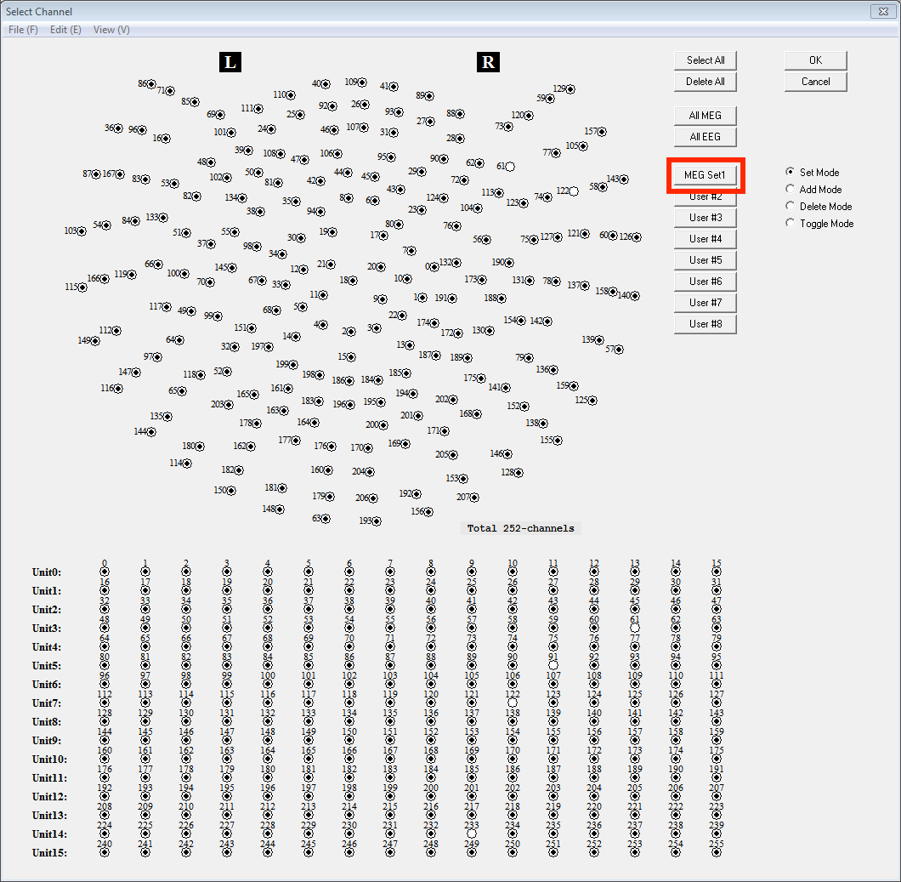

Finally, add the participant number to the ‘Patient ID’ box and the experiment name to ‘Patient Name’. This will save recordings automatically with both the ID and experiment names. Also make sure that the data is being saved to the correct lab folder within the D:\MEGDATA location.

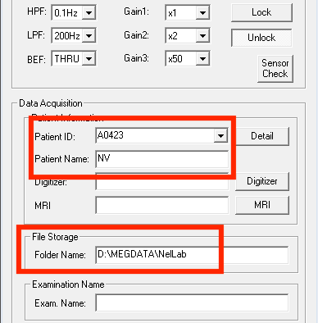

#### Record

* **ONCE THE DOOR IS CLOSED, YOU CAN LOCK THE SENSORS**
* Display your experiment for the participant, and check with them if they can see clearly.
  + This is to check if the projector is actually on! If not, you’ll need to unlock the sensors and turn it on.
* Once everything is in place, instruct participants to stay still while you take a marker measurement.
  + Make sure to take marker measurements before acquisition & after you abort! Marker measurements are the files that sandwich the MEG .con file.
  + On “Monitor and Acquisition” window, Marker measurement > Start > OK

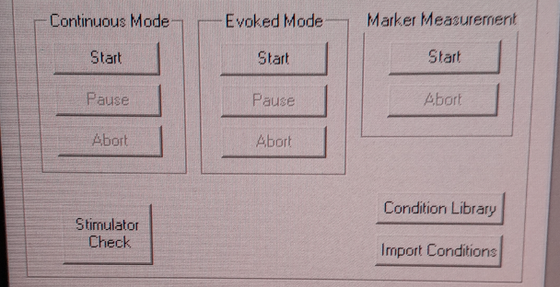

* + When done, column ‘GOF%’ should be around 99%
  + You need a minimum of 3 coils to properly localize the head, so if there are fewer than that you must redo the measurement
* After the marker measurement is complete, you can begin recording your experiment.
  + Make sure the microphone is off
  + On “Monitor and Acquisition” window, Continuous Mode > Start
  + Check that the sampling rate is set to 1000 Hz and the time is set to 4000 seconds
  + During recording, please make sure to keep voices low. The MSR does a poor job at shielding sounds (this is especially important if you’re doing an auditory study).
  + Once the recording has begun, you may start your experiment from the stimulus PC
* Take note of how the participant is doing. If they appear to be drowsy in the eye-tracker, pause your experiment if possible and do reasonable things to wake them up. Drowsy subjects don’t engage with your task and usually don’t produce great data.
* Once the experiment is complete, stop the recording and save the data.
  + On “Monitor and Acquisition” window, Continuous Mode > Abort.
  + Take another marker measurement
  + **UNLOCK THE SENSORS AND COMPLETELY CLOSE THE MEG160 PROGRAM**
* Take participant out of the MSR
  + **DOUBLE CHECK THAT THE SENSORS ARE UNLOCKED**
  + Open the MSR door
  + Tell the participant they may come out of the helmet, or use the wheel on the bed to roll them out.
  + When removing the head-position indicator coils and earphones, do the removal yourself. The coils in particular are very fragile and expensive. Remove with care.
  + At this point, the participant is free to go. Remember to pay them!

| **If your colleague is running an experiment, please be considerate and keep your voice down!** |
| --- |

#### Common noise patterns

There are lots of things that can introduce noise into an MEG recording. Generally, a bit of noise will not affect the success of your experiment as long as there are enough high-quality trials to balance out. However, it is ultimately up to the experimenter whether a participant has too much noise in their recording and should be excluded from the experiment. The best recordings are those in which the sensors look almost entirely flat, so the more your recording deviates from that the more difficult it will be to detect any experimental effects. If you are unsure about a noise pattern and it does not disappear on its own, stop your experiment and take video of the noise to share with KIT or another MEG technician.

* Single sensor noise - this is noise that just appears on a single channel (122 in the image below) and does not spread to other channels. Usually this will happen for a few sensors every session, it is okay to proceed with the experiment and then exclude those channels from your analysis.

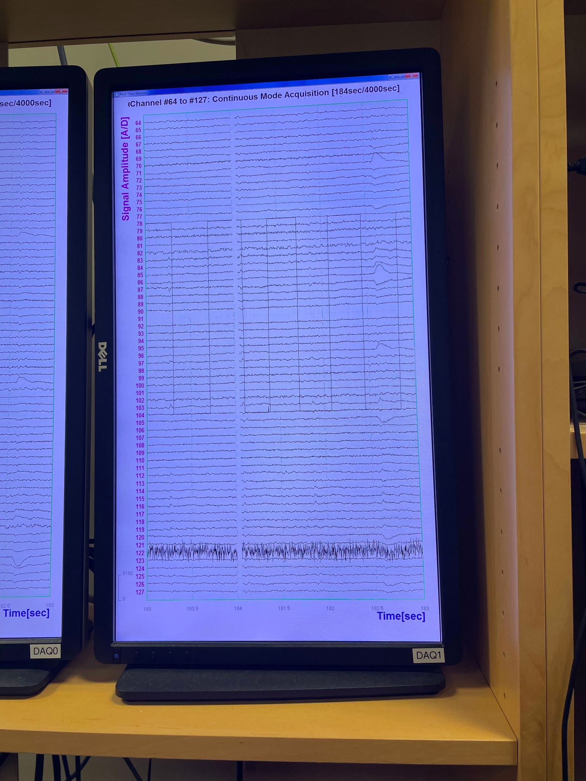

* Alpha waves - this sinusoidal noise happens when a participant is tired. It can mask other brain signals of interest, so it’s a good idea to try to minimize this kind of noise. If you start to see a lot of it, try to give your participant a break from your task to wake them up a bit. If that doesn’t work, it may be a good idea to reschedule the session for another day.

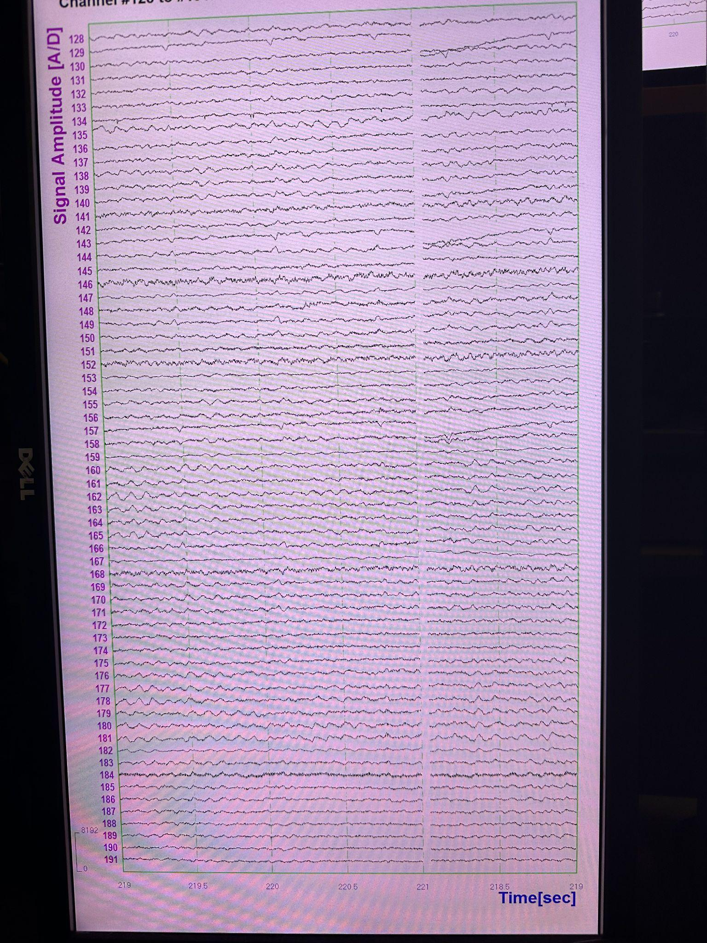

* Car - this low frequency noise can happen when a car drives by. It usually lasts 30 seconds to a minute.

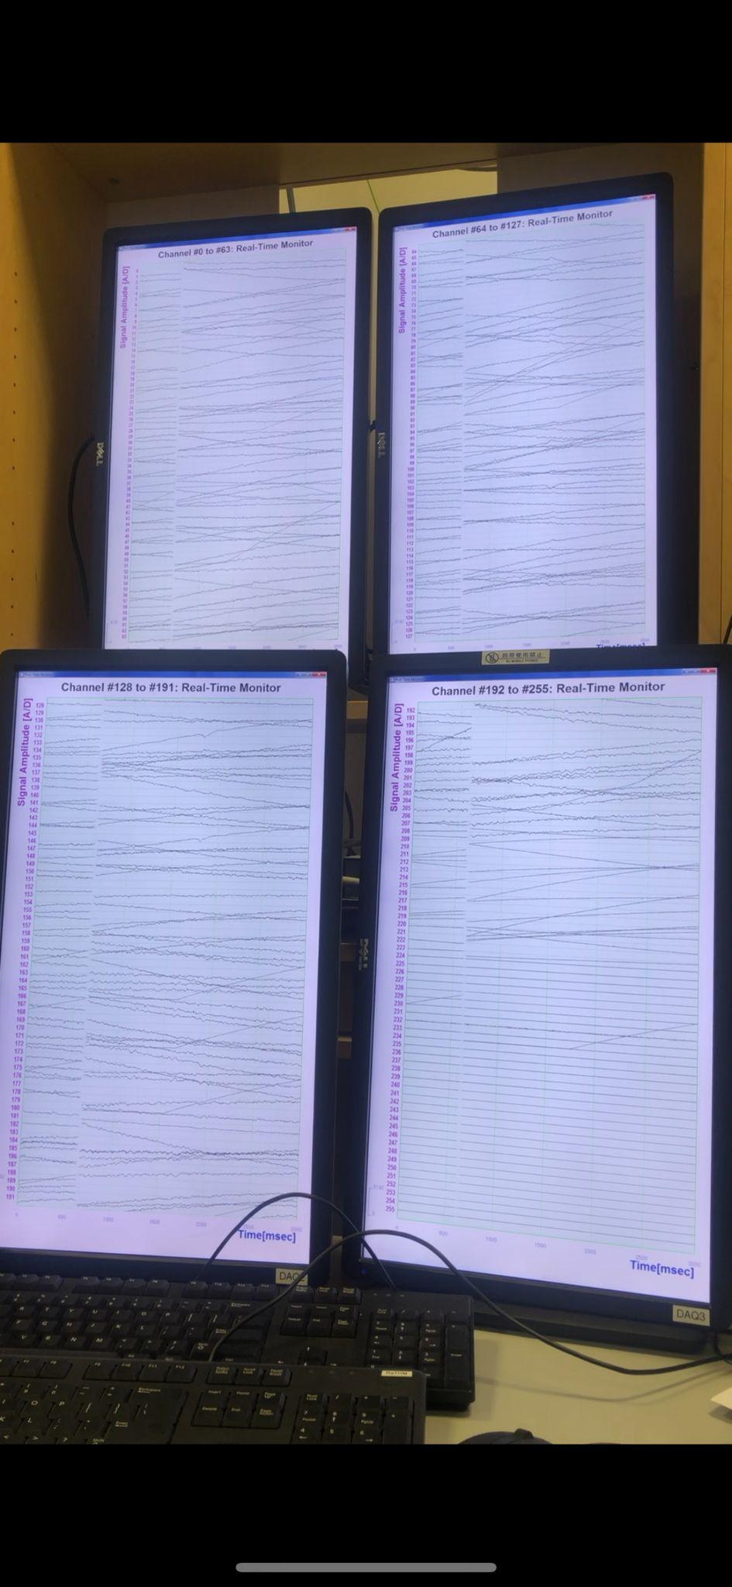

* Movement - this is very high frequency noise that you will see across a large number of channels in bursts. If subjects are moving a lot, remind them to be still because any movement will ruin a trial.

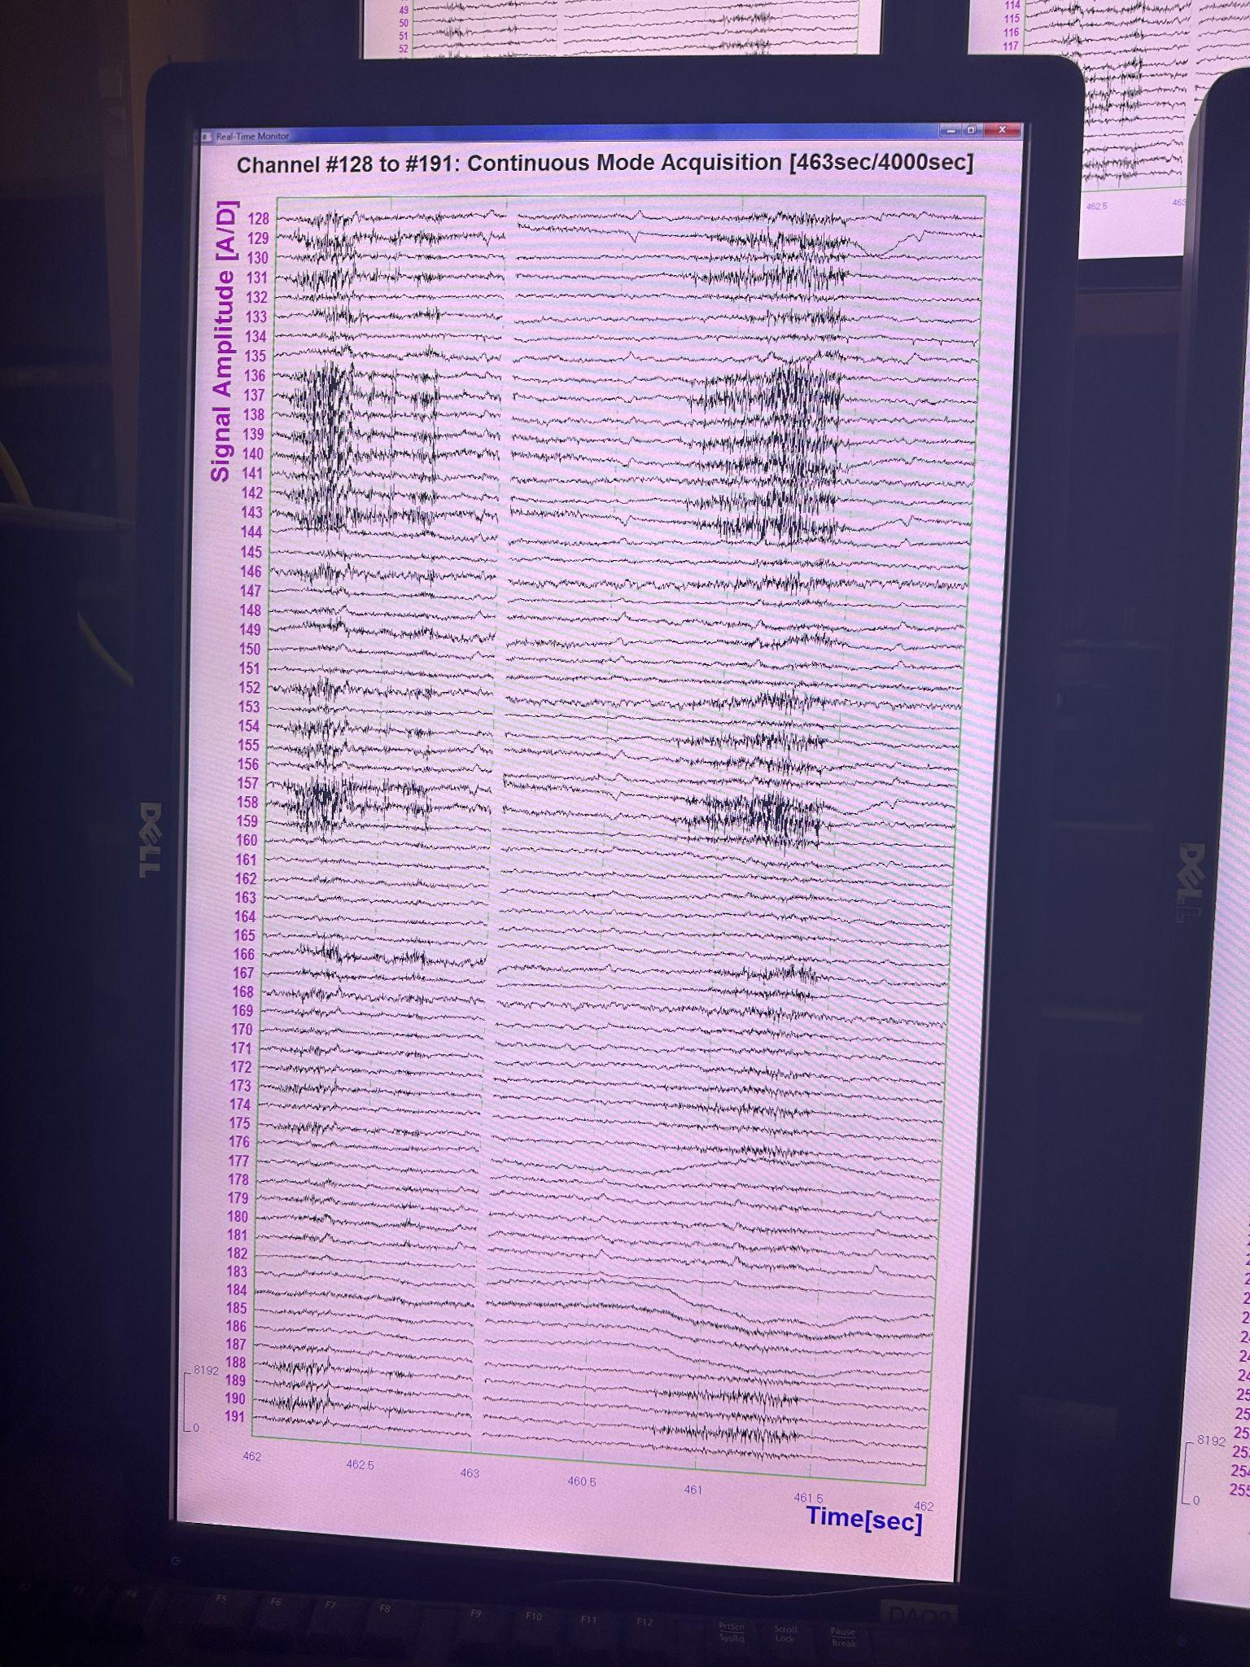

* Heartbeat - this will be a consistent periodic dip or spike in the signal. It is very regular and can be removed with ICA. It will be visible on most of the channels.

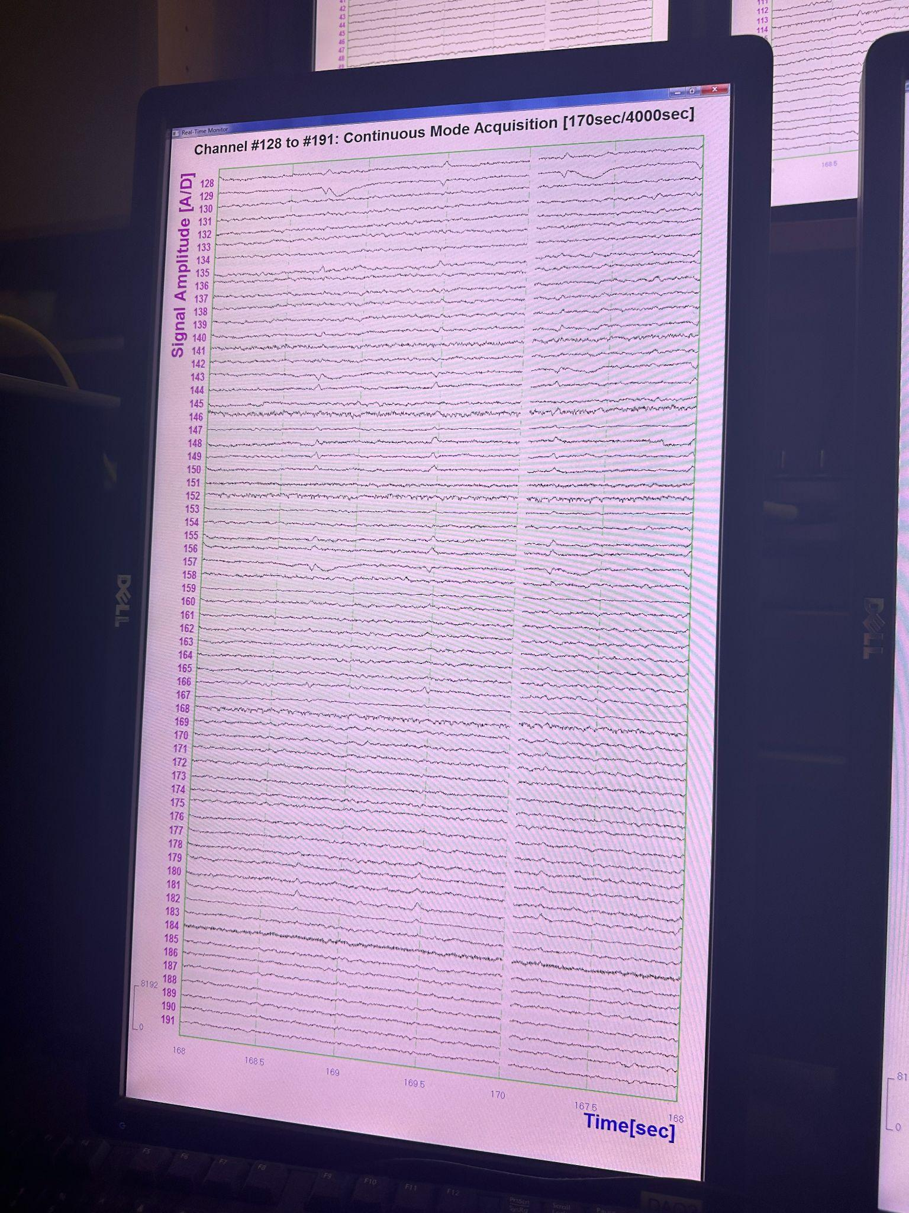

* Eyeblinks - this is another relatively consistent kind of noise. The change in activity will be both greater and longer than for heartbeats, but it can also be eliminated using ICA in data preprocessing. It usually does not spread across a majority of the channels.

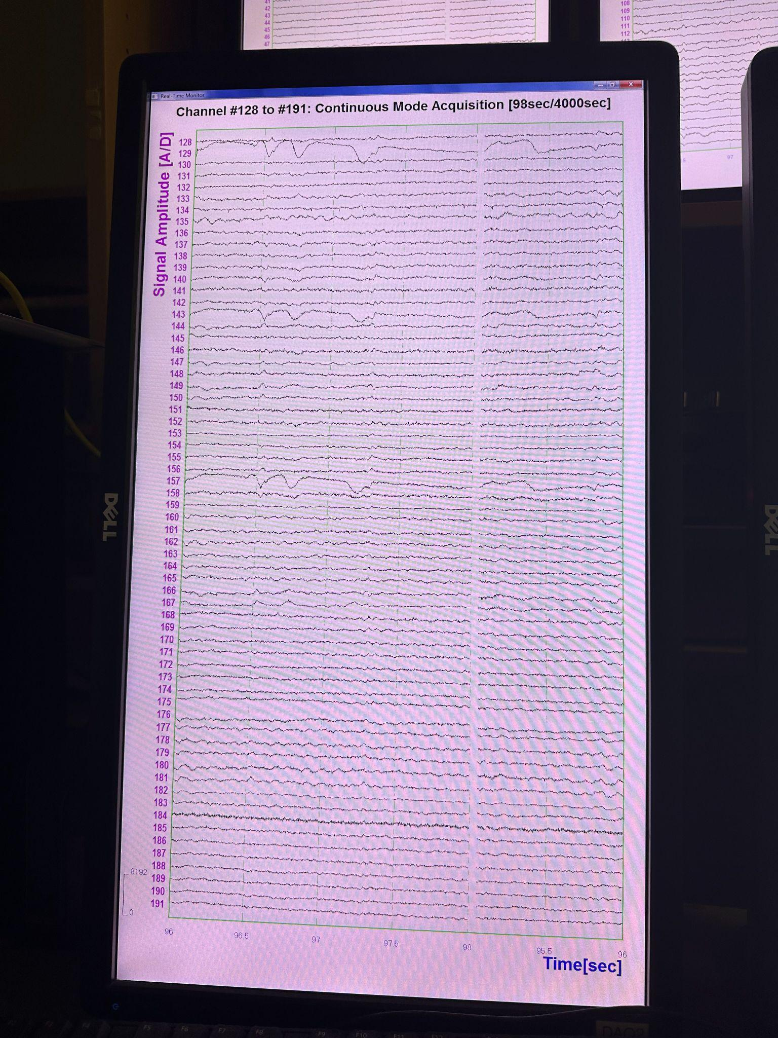

* Phone/bluetooth - this noise will appear when phone or radio waves interfere with the sensors. It is very high frequency and will usually go away after 10-15 seconds. In rare occasions, it can “oversaturate” a channel and make it unusable for the rest of the recording. This is why it is important to make sure all phones are on airplane mode and security knows when experiments are happening so that they can turn off their radios.

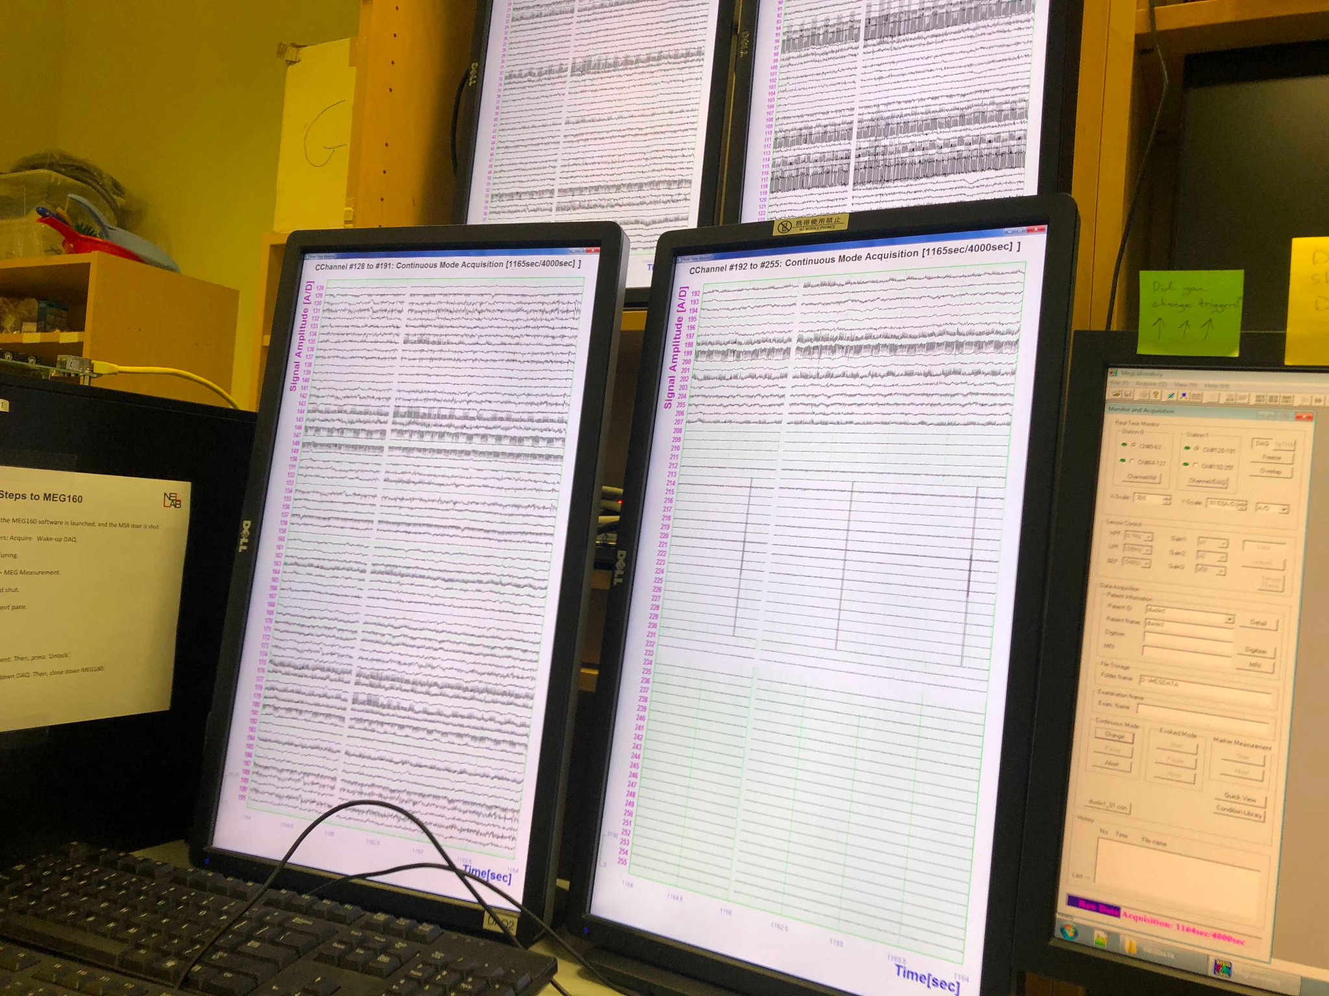

* Metal - generally any noise that does not fall into one of the categories above will be metal. The patterns can vary in how many channels it spreads across and the shape of the waveform (although it is generally aperiodic), but importantly this kind of noise will not disappear or be eliminated in post-processing. If you suspect a subject has metal on them, they must be removed from the MEG and the experiment cannot continue. 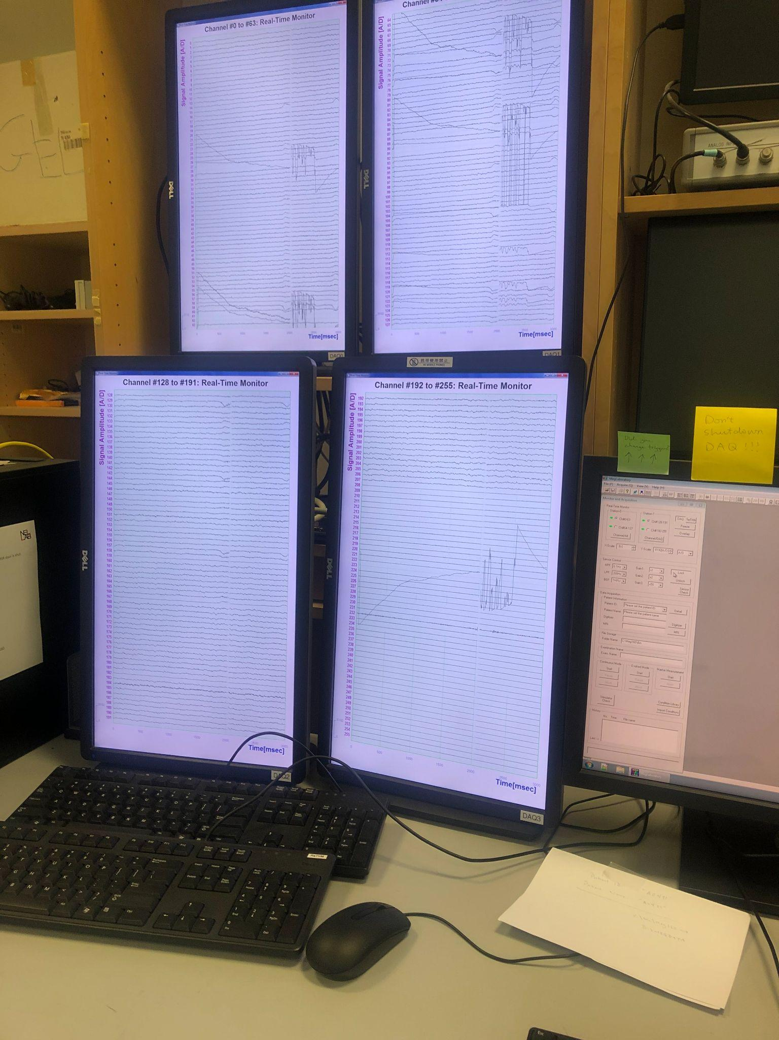

#### Finishing up

At the end of the experiment, several things to finish up:

* **Turn on the heater cable.**
* **Double check that you turned the heater cable back on.**
* **Check again.**
* Clean the helmet, head-position indicator coils, and button box with alcohol wipes.
* Remove sheets, fold, and place NEATLY in the laundry bag in the participant room.
* Wipe down the FastScan neck brace and any other surfaces the participant came in contact with
* In PyPixx GUI, put on sleep mode the Projector, and close PyPixx GUI.
* Switch off the camera monitor of the MEG
* Turn off the FastScan device
* Do not shut down any of the computers. They can all be locked or logged off.
* (Legacy) Turn off the sound board. If you changed the microphone set up for your stimulus presentation, be sure to reconnect everything to the way you found it.
* *Turning the eye tracker off is tricky. Doing it incorrectly can (maybe) cause an error that means it will not turn back on. Best of luck! (And please update this if anyone figures out the correct way to do it.)*
* Turn off the MSR lights.

#### Cleaning and Uploading Data

* **Generating a Noise Reduced (NR) File**
  + *This is assuming you’ve already saved your .con file on the MEGPC!*
  + Go to the MEGDATA folder and look for your participant’s .con file(s)
  + Once you found it, click on it to open it in MEG160
  + Go to Edit > Noise Reduce > Execute > Save As
  + Once you have generated the noise reduced file, delete it from MEGDATA to conserve space (do not delete raw .con file)
* **Naming Conventions**
  + **.CON File →** this is automatically named into subjectID_01_analysis_01.con, *so you don’t have to do anything*
  + **Noise Reduced .con File** **→** add an _NR at the end of your regular .con file (subjectID_01_analysis_01_NR.con)
  + **Fastscan File →** subjectID_expname_DayMonthYear.fsn
  + **Fastscan Basic Surface →** subjectID_expname_DayMonthYear_basic.txt
  + **Fastscan Points →** subjectID_expname_DayMonthYear_points.txt
  + **Fiff File →** subjectID_expname-raw.fiff
* **FastScan Instructions**
  + Click on ‘Select’ and start dragging your mouse over areas you want to delete
  + To delete points you’ve selected, simply click on the backspace key on your keyboard
  + Then go to Edit > Generate Surface
    - Smoothing = 5mm
    - Decimation = 3mm
  + In the pop-up, click on Apply Basic Surface, then close it
  + To save your headscan, go to File > Save As > **subjectID_expname_DayMonthYear.fsn**
  + To save your basic surface, go to File > Export As > Basic Surface > **subjectID_expname_DayMonthYear_basic.txt**
  + You will get a pop-up asking if you want to save the stylus points, click yes and save it as **subjectID_expname_DayMonthYear_points.txt**
* Upload all of these files (and the marker files) to your lab’s server. Files are periodically deleted in order to free up storage space, so **you should never use any of the lab machines for permanent file storage.**

### TROUBLESHOOTING

#### Fixing Noisy Waveforms on the DAQ

**Did you remember to:**

* Put your experiment in the Public Safety calendar and remind security to turn radios off?
* Turn off the heater?
* Autotune before acquisition?
* Remind the participant that lying still is key to good data?
* Ask the participants to remove all metal?
* Ask the participants about a possible metal retainer or dental work?
* Ask the participant to change into the metal-free mask?
* Is your phone in the MSR?
* Check that the filters and viewing scales are the correct values?
  + For NeLLab, use the following values:

High-pass filter: 0.10Hz

Low-pass filter: 200Hz

BEF: THRU

X-scale: 3[s] - the scale values must be set using the up/down arrows

Y-scale: 8192[A/D]

Sampling rate: 100

#### Fixing dead waveforms on the DAQ / Restarting DAQs / Power Shutdown

* If the power goes out in the lab, sometimes the DAQ electronics need to be reset. In general, the numbers on the DC converter should look something likethe ones in the photo below. If they do not, follow the procedure below to restart things and see if they return to normal.
  + Turn off all the computers
  + Turn the DC power supply in the rightmost cabinet off and on. The buttons are labeled in the order that things should be turned on, so to turn off press 2 -> 1, and to turn on press 1 -> 2. Turn off the left unit first, then the right one, and turn them back on in the reverse order. **[DOUBLE CHECK WITH JEFF/KIT THAT THIS IS CORRECT]**
  + Turn on the MEG MAIN PC
  + Open MEG160 on the MEG MAIN PC
  + Under “Aquire” in MEG160 click “Wake up DAQ”

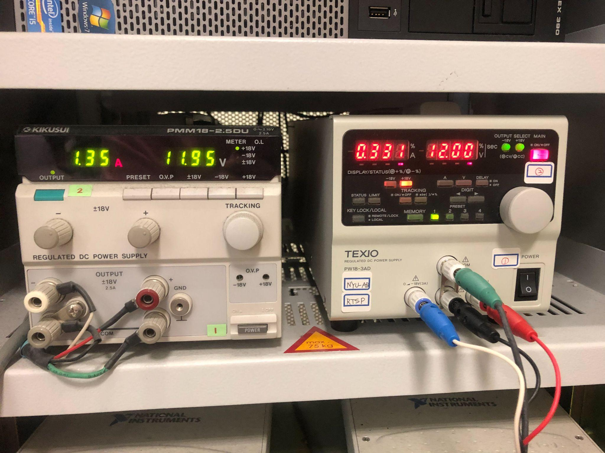

#### Marker Coil Errors

* Check that marker coil box is turned on
* Check that marker coil driver batteries are charged fully
* Check that switches on the back of the driver are set to **10 uA and x10**
* If the marker measurements continue to fail, save the file, and loop in KIT and/or Jeff

#### Trigger Box Not Working

* In cases where your get an error saying “StimTracker not found”, try one or more of the following:
  + Make sure that the Stim Windows is on.
  + Try closing pieces of software that might be interfacing with the StimTracker (e.g. PsychoPy GUI).
  + Restart Stim Mac.
  + Restart Stim Windows.
* If you’re using the Mac, make sure the PC is also turned on

#### Server is disconnected

* On Mac
  + In Finder, click ‘Go’ that’s on the menu bar, and click on ‘Connect to Server…’
  + Type in the Abu Dhabi server link: smb://rcsfileshare.abudhabi.nyu.edu/MEG
  + Click ‘Connect’
  + Use your NetID & password to connect the server as a ‘Registered User’, not ‘Guest’
  + ***NOTE:*** if you’re trying to access the server off-campus, make sure to connect the NYU VPN first!
    - First password: your NetID password
    - Second password: push
* On Windows
  + Go to ‘This PC’ & click on ‘Map network drive’ that’s on the menu bar
  + Next to Folder, type in the server link: \\rcsfileshare.abudhabi.nyu.edu/MEG and click ‘Finish’
  + Then it will ask for your NetID & password (remember to put ad\ before your NetID! Eg: ad\ts09)
  + ***NOTE:*** You won’t always have to connect to the server this way, sometimes you’ll see that the server is already under ‘Computer’ on the left-hand side (with a bold red cross), in that case just click on it and put in your ad\NetID and password
  + ***I GOT AN ERROR!*** If you get an error after putting in your NetID & password about the server being logged off, wait a couple of minutes and try again
* **SERVER LINKS**
  + **Abu Dhabi NeLLab Server:** smb://rcsfileshare.abudhabi.nyu.edu/MEG
    - *Contact Kainaath for access (kainaath.mumtaz@nyu.edu)*
  + **New York NeLLab Server:** smb://nellabny.psych.nyu.edu/server
    - *Contact Jacqui for access (*[*jj3479@nyu.edu*](mailto:jj3479@nyu.edu)*)*
  + Your lab probably has its own server, which can be added to the machines for file transferring.
  + **MRI Server:** smb://rcsfileshare.abudhabi.nyu.edu/mri-nellab
    - * *Contact Haidee Paterson for access after completing MRI training (hp42@nyu.edu)*

#### FastScan is not working

* Try adjusting the lighting around the participant by turning on/off the lamp on the desk
* Try changing the lighting sensitivity by selecting **Scanner > Properties > AGC > Scan dark surfaces.**
* Use the old FastScan instead
  + Place the reference tripod next to the participant, and adjust accordingly to their height (the closer to their head, the better the result). Use the lines on the tripod to orient it correctly. The tripod should be roughy in line with the participant’s shoulders
  + Light blue caps are on the end of the shelf with sheets and pillowcases in participant room
  + The settings on the laser gun will depend on the color of the surface the gun is scanning:
    - Cap: usually 4/5 is good
    - Lighter skin: 2
    - Darker skin: 3 or 4

#### Liquid helium refill fails

* CONTACT KIT ASAP WITH A DESCRIPTION OF THE PROBLEM AND PICTURES OF HELIUM METER AND ANY OTHER (POSSIBLY) RELATED ISSUES
* Make sure the LHe level meter for the dewar is turned off (the green “Supply” light should not be lit up), if left on it can push up the evaporation rate in the dewar and the LHe level in the dewar can rapidly go down to zero
* Possibly a problem with the position of the transfer tube in the helium tank being too high during the refill, or a vacuum has been broken in one of the transfer tubes

#### Eye Tracker won’t turn on

* Sometimes the eye tracker gets stuck on a “Dual BIOS” screen, and none of the options to exit work. So far, the only solution is to keep turning it on and off or just wait a while and come back to it.

### MEG MAINTENANCE

Regular maintenance should be done for the MEG so that things keep working properly. Normally Jeff or KIT would oversee this when they visit Abu Dhabi, but occasionally we have to do things as well if they cannot make it. These are the most important things to keep up with, how often they should be done, and when they were last performed.

#### Vacuuming helium transfer tube

*Last completed: November 2021*

* Anatomy of the MEG: <https://docs.google.com/document/d/1mtIl_7MK_gYYgT_cvVbqQPwVB_pM1BKss_-V1UWPcdg/edit?usp=sharing>
* Video of how to pump dewar (transfer tube process is very similar):

<https://drive.google.com/file/d/15rMRAguBxASBpbbhD69LCP416WVF_8NP/view>

* The plunger for vacuuming the transfer tube is kept in a brown cardboard box on the shelf in the space behind the stim PC
* To connect the Pirani gauge (pressure meter) to the vacuum pump you will need the T-shaped connector to be temporarily removed from the helium recycling system and attached to the pump and gauge. Adnan or Tariq (or Serco people who usually do the helium refill) can help with this.
* The manual for operating the vacuum pump is [here](https://manualzz.com/doc/14180439/gld-136a-201a-manual)

#### Changing DAQ batteries

*Last completed for DAQ0: February 2020*

#### Changing Marker Coil Batteries

Make sure to periodically recharge the batteries for the marker coils. The charger is located alongside the MSR near the shelves.

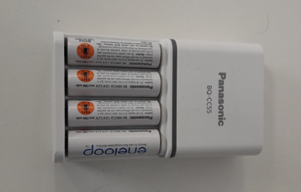

#### Making Sure Helium System is Operating

The liquid helium is integral to the operation of the MEG. The dewar needs to have helium in it at all times in order to keep the sensors functional. To make sure this is possible, it is important to keep an eye on the helium recycling system and be aware of any potential issues before the helium in the dewar runs out.

First, watch the external and internal helium transfer tubes during the helium refills. If either of them get cold, it means they have lost their vacuum seal and need to be pumped (see earlier section).

Additionally, if the level of the helium depletes faster than usual, that could be an indication a vacuum is leaking somewhere. The levels of the helium before and after the weekly refill are tracked [here](https://docs.google.com/spreadsheets/d/14-yHq_U9Un0HXIno1-XeL928Vmv2yO2f/edit?usp=sharing&ouid=114905498842114594031&rtpof=true&sd=true), if anything looks suspicious reach out to KIT and ask for further instructions.

### OTHER GUIDES

* [NeLLab general manual](https://docs.google.com/document/d/13Ru10MdwZ5xhlK_V7O99RO26oswxldJ6u0MrFhPDGpk/edit?usp=sharing) - written by NY, has information about general lab culture, expectations, etc.
* Analysis Start Up guide - written by NY, has information about what packages and software to install to analyze MEG data
  + Located on NY server - afp://nellabny.psych.nyu.edu/Server/NEUROLING/Manuals and Tutorials/Getting Started/getting_started.pdf
* [MEG Analysis tutorial](https://docs.google.com/document/d/1Sbisuxryh0WAjXMNdH1KOpQ-hLavHl20/edit?usp=sharing&ouid=103140868927184072595&rtpof=true&sd=true) - written by Dustin, has step-by-step instructions of how to preprocess and analyze MEG data
* MRI pipeline tutorial - written by Graham/Ben, has information about how to process MRIs for use in coregistration
  + Located on AD server -

smb://rcsfileshare.abudhabi.nyu.edu/MEG2/MRI_Data/Nellab_MRI_Pipeline_Apr2021.pdf

* [MEG160 analysis guide](https://docs.google.com/document/d/1saohBcsoW1FV32TVRwdxPB0Ibm5MqG8H2AQriYUUdnk/edit?usp=sharing) - written by Kyra, has information on how to use MEG160 to do very basic sensor space visualization as well as a tutorial on how to run a two-tone test for lab demonstrations
* [MEG160 manual](https://drive.google.com/file/d/1tV4c_hti1Az-c-h_oBZwQ5hpK0_9yBZO/view?usp=sharing) - information about program used to record and noise reduce MEG data
* [MEG160 on Macs](https://docs.google.com/document/d/1ena4DaoX2M-iNX7XyAnkYSc_Q05owu8X/edit?usp=sharing&ouid=103140868927184072595&rtpof=true&sd=true) - how to install MEG160 on Macs to do analysis outside of the lab